## Natural Language Processing in TensorFlow

#### Introduction

* In the earlier courses in this specialization, you got an introduction to machine learning and deep learning with a heavy focus on computer vision problems. You learned about neural networks and how they can match patterns to perform classifications. And then how you can give them new data and have them predict what they might be seeing.
* You learned how to make that a little smarter for images using convolutions to identify the features in the images and classify based on those instead of just matching on raw pixels. This helped you classify images for more real world style ones instead of using a very controlled environment.
* In this course we're going to go back to building models but we'll focused on text and how you can build classifier is based on text models. We'll start by looking at sentiment in text, and learn how to build models that understand text that are trained on labelled text, and then can then classify new text based on what they've seen.
* When we were dealing with images, it was relatively easy for us to feed them into a neural network, as the pixel values were already numbers. And the network could learn parameters of functions that could be used to fit classes to labels.
* But what happens with text? How can we do that with sentences and words?

#### Word based encodings

* We could take character encodings for each character in a set.
* For example, the ASCII values.
* But will that help us understand the meaning of a word? So for example, consider the word 'LISTEN' as shown here.

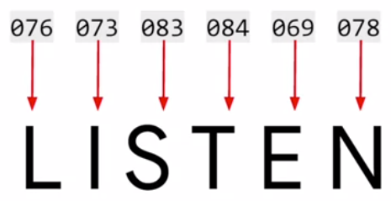

* A common simple character encoding is ASCII, the American Standard Code for Information Interchange with the values as shown here.
* So you might think you could have a word like LISTEN encoded using these values.
* But the problem with this of course, is that the semantics of the word aren't encoded in the letters.

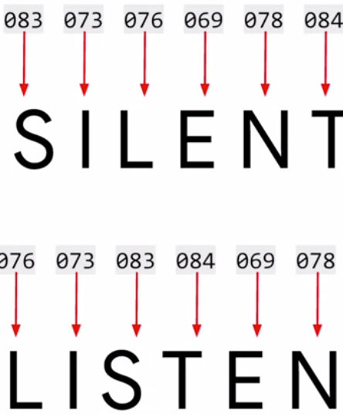

* This could be demonstrated using the word 'SILENT ' which has a very different and almost opposite meaning, but with exactly the same letters.
* So it seems that training a neural network with just the letters could be a daunting task.
* So how about if we consider words? What if we could give words a value and have those values used in training a network?
* So for example, consider this sentence, I Love my dog.
* How about giving a value to each word? What that value is doesn't matter.
* It's just that we have a value per word, and the value is the same for the same word every time.

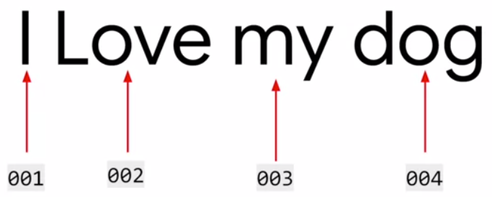

* So a simple encoding for the sentence would be for example to give word 'I' the value one. Following on, we could give the words 'Love', 'my' and 'dog' the values 2, 3, and 4 respectively.
* So then the sentence, I love my dog would be encoded as 1, 2, 3, 4.
* So now, what if I have the sentence, I love my cat?
* Well, we've already encoded the words 'I love my' as 1, 2, 3.
* So we can reuse those, and we can create a new token for cat, which we haven't seen before.
* So let's make that the number 5.
* Now if we just look at the two sets of encodings, we can begin to see some similarity between the sentences.
* I love my dog is 1, 2, 3, 4 and I love my cat is 1, 2, 3, 5.
* So this is at least a beginning and how we can start training a neural network based on words.
* Fortunately, TensorFlow and Care Ask give us some APIs that make it very simple to do this. We'll look at those next.

#### Using APIs

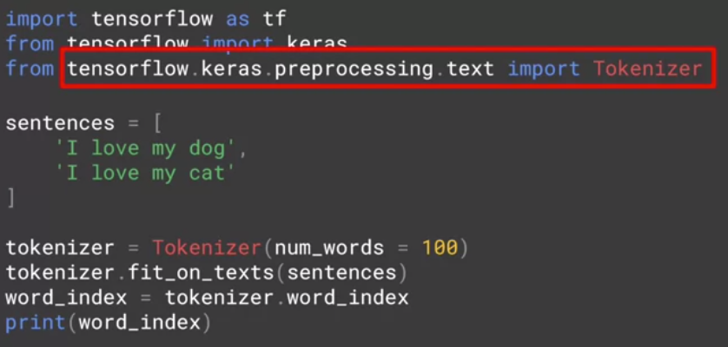

* Here's the code to encode the two sentences that we just spoke about.
* Tensorflow and keras give us a number of ways to encode words, but the one I'm going to focus on is the *tokenizer.*
* *This will handle the heavy lifting for us, generating the dictionary of word encodings and creating vectors out of the sentences.*
* Then create an instance of the tokenizer.
* A passive parameter *num* wards to it.
* In this case, I'm using 100 which is way too big, as there are only five distinct words in this data.
* If you're creating a training set based on lots of text, you usually don't know how many unique distinct words there are in that text.
* So by setting this hyperparameter, what *the tokenizer will do is take the top 100 words by volume and just encode those.*
* It's a handy shortcut when dealing with lots of data, and worth experimenting with when you train with real data.
* Sometimes the impact of less words can be minimal and training accuracy, but huge in training time, but do use it carefully.
* *The fit on texts method of the tokenizer then takes in the data and encodes it.*
* The tokenizer provides a word index property which returns a dictionary containing key value pairs, where the key is the word, and the value is the token for that word, which you can inspect by simply printing it out. You can see the results here.



* Remember when we said that the word I was capitalized, note that it's lower-cased here.
* That's another thing that the *tokenizer* does for you.
* *It strips punctuation out.*
* This is really useful if you consider this case.
* Here, I've added another sentence, 'You love my dog!' but there's something very different about it.
* I've added an exclamation after the word 'dog!'
* Now, should this be treated as a different word than just dog?
* Well, of course not.
* So the results of the code that we saw earlier with this new corpus of data, will look like this.



* Notice that we still only have 'dog' as a key.
* That the exclamation didn't impact this, and of course, we have a new key for the word 'you' that was detected.
* So you've seen the beginnings of handling texts by creating word-based encodings of that text, with some very simple code intensive flow and keras.

## Check out the code!

Let's take a look at the first [notebook](https://colab.research.google.com/github/lmoroney/dlaicourse/blob/master/TensorFlow%20In%20Practice/Course%203%20-%20NLP/Course%203%20-%20Week%201%20-%20Lesson%201.ipynb) .

Note:

1. Is that punctuation like spaces and the comma, have actually been removed. So it cleans up the text and pulls out the words.
2. You may have noticed that I have a lowercase i here and an uppercase I here. As you can see to make a case insensitive, it's just using I and it's giving the same token for both of these.

#### Text to sequence

* In the previous lesson, you saw how to tokenize the words and sentences, building up a dictionary of all the words to make a corpus.
* The next step will be to turn your sentences into lists of values based on these tokens.
* Once you have them, you'll likely also need to manipulate these lists, not least to make every sentence the same length, otherwise, it may be hard to train a neural network with them.
* Remember when we were doing images, we defined an input layer with the size of the image that we're feeding into the neural network.
* In the cases where images where differently sized, we would resize them to fit.
* Well, you're going to face the same thing with text.

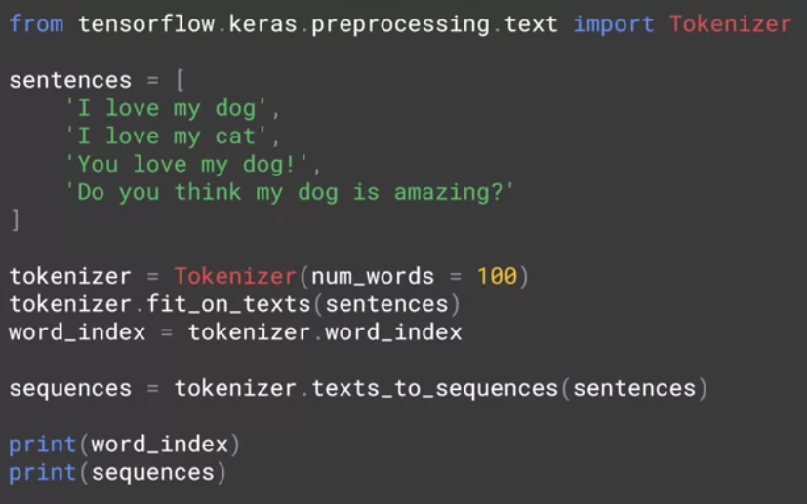

* Let's start with creating a list of sequences, the sentences encoded with the tokens that we generated and I've updated the code that we've been working on to this.
* First of all, I've added another sentence to the end of the sentences list.
* The next piece of code is this one, where I simply call on the tokenizer to get texts to sequences, and it will turn them into a set of sequences for me.
* So if I run this code, this will be the output.

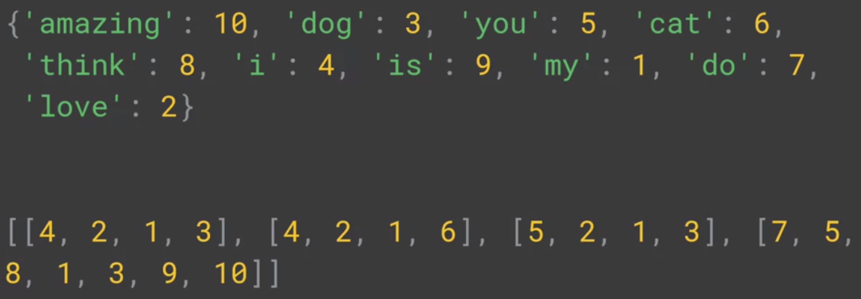

* At the bottom is my list of sentences that have been encoded into integer lists, with the tokens replacing the words.
* So for example, I love my dog becomes 4, 2, 1, 3.
* One really handy thing about this that you'll use later is the fact that the *text to sequences called can take any set of sentences, so it can encode them based on the word set that it learned from the one that was passed into fit on texts.*
* This is very significant if you think ahead a little bit.
* If you train a neural network on a corpus (entire paragraph or all the texts) of texts, and the text has a word index generated from it, then when you want to do inference with the train model, you'll have to encode the text that you want to infer on with the same word index, otherwise it would be meaningless.
* So if you consider this code.

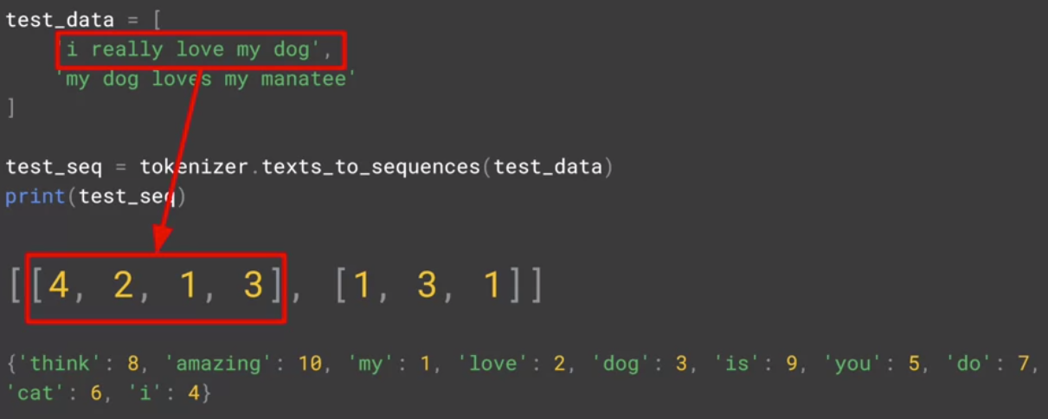

* There are some familiar words here, like love, my, and dog but also some previously unseen ones.
* If I run this code, this is what I would get.
* I've added the dictionary underneath for convenience.
* So I really love my dog would still be encoded as 4, 2, 1, 3, which is 'I love my dog' with 'really' being lost as the word is not in the Word Index, and 'my dog loves my manatee' would get encoded to 1, 3, 1, which is just 'my dog my'.

#### Looking more at the Tokenizer

* So what do we learn from this?
* First of all, we really need a lot of training data to get a broad vocabulary or we could end up with sentences like, my dog my, like we just did.
* Secondly, in many cases, it's a good idea to instead of just ignoring unseen words, to put a special value in when an unseen word is encountered.
* You can do this with a property on the tokenizer. Let's take a look.
* Here's the complete code showing both the original sentences and the test data.

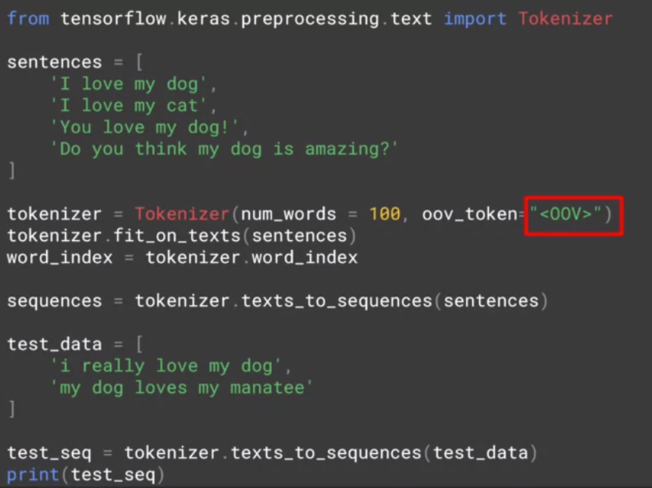

* What I've changed is to add a property oov token to the tokenizer constructor.
* You can see now that I've specified that I want the token *oov for outer vocabulary to be used for words that aren't in the word index.*
* You can use whatever you like here, but remember that it should be something unique and distinct that isn't confused with a real word.
* So now, if I run this code, I'll get my test sequences looking like this.

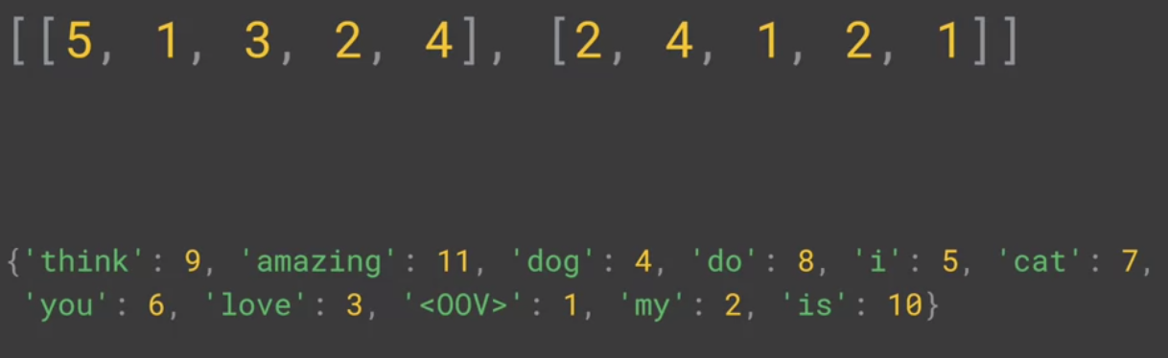

* I pasted the word index underneath so you can look it up.
* The first sentence will be, i out of vocab, love my dog.
* The second will be, my dog oov, my oov, still not syntactically great, but it is doing better.
* As the corpus grows and more words are in the index, hopefully previously unseen sentences will have better coverage.

Note: In dictionary things are going to be sorted into their order of commonality.

* Next up is padding.
* As we mentioned earlier when we were building neural networks to handle pictures.
* When we fed them into the network for training, we needed them to be uniform in size.
* Often, we use the generators to resize the image to fit for example.
* With texts you'll face a similar requirement before you can train with texts, we needed to have some level of uniformity of size, so padding is your friend there.

#### Padding

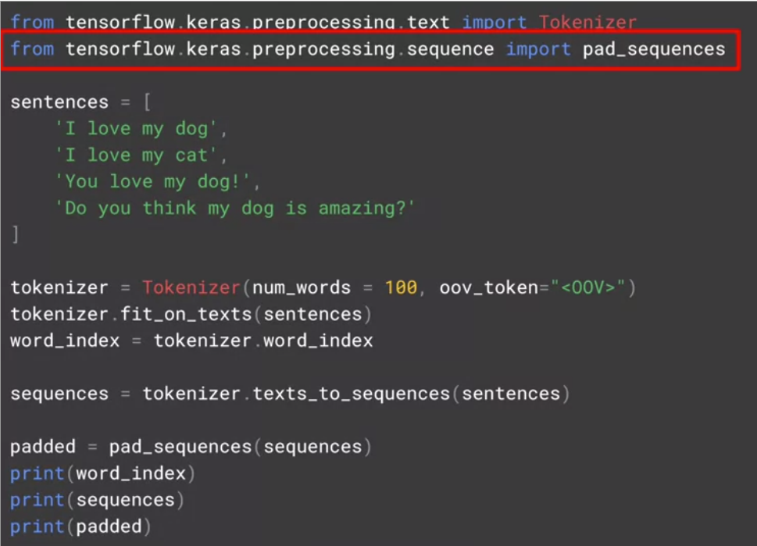

* Here's the complete listing and we'll break it down piece by piece.
* First, in order to use the padding functions you'll have to import pad sequences from tensorflow.keras.preprocessing.sequence.
* Then once the tokenizer has created the sequences, these sequences can be passed to *pad sequences* in order to have them padded like this.

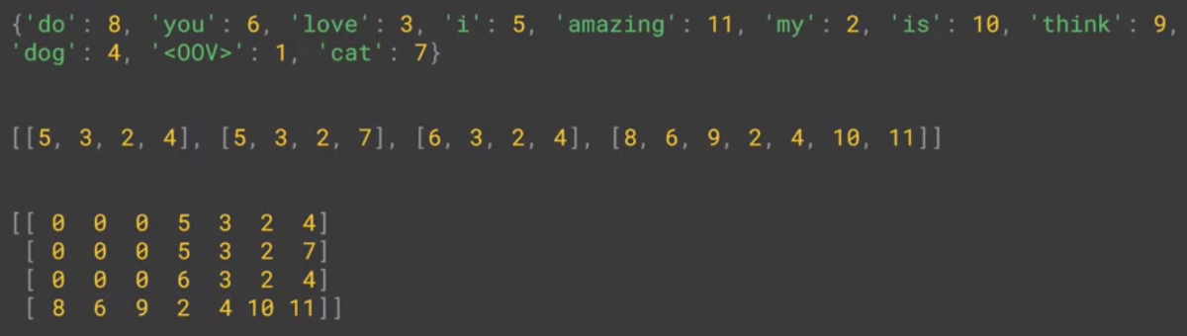

* You can now see that the list of sentences has been padded out into a matrix and that each row in the matrix has the same length.
* It achieved this by putting the appropriate number of zeros before the sentence.
* So in the case of the sentence 5.3.2.4, it didn't actually do any.
* In the case of the longer sentence here it didn't need to do any.
* Often you'll see examples where the padding is after the sentence and not before as you just saw.
* If you, like me, are more comfortable with that, you can change the code to this, adding the parameter padding equals post.

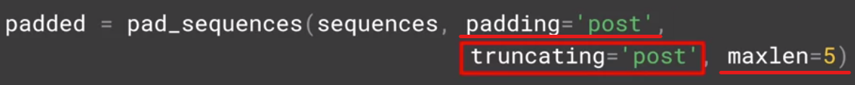

* You may have noticed that the matrix width was the same as the longest sentence.
* But you can override that with the maxlen parameter.
* So for example if you only want your sentences to have a maximum of five words.
* This of course will lead to the question.
* If I have sentences longer than the maxlength, then I'll lose information but from where.
* Like with the padding the default is pre, which means that you will lose from the beginning of the sentence.
* If you want to override this so that you lose from the end instead, you can do so with the truncating parameter like this. So you've now seen how to encode your sentences, how to pad them and how to use Word indexing to encode previously unseen sentences using out of vocab characters.

## Check out the code!

Take a look at the second [notebook](https://colab.research.google.com/github/lmoroney/dlaicourse/blob/master/TensorFlow%20In%20Practice/Course%203%20-%20NLP/Course%203%20-%20Week%201%20-%20Lesson%202.ipynb#scrollTo=rX8mhOLljYeM) .

#### Sarcasm, really?

* So far, you've been looking at texts, and how to tokenize the text, and then turn sentences into sequences using the tools available in TensorFlow.
* In this lesson, we'll take a look at some public data-sets and how you can process them to get them ready to train a neural network.
* We'll start with this one published by Rishabh Misra with details on Kaggle at this link. It's a really fun CC0 public domain data-set at all around sarcasm detection.



* This data-set is very straightforward and simple, not to mention very easy to work with.
* It has three elements in it.

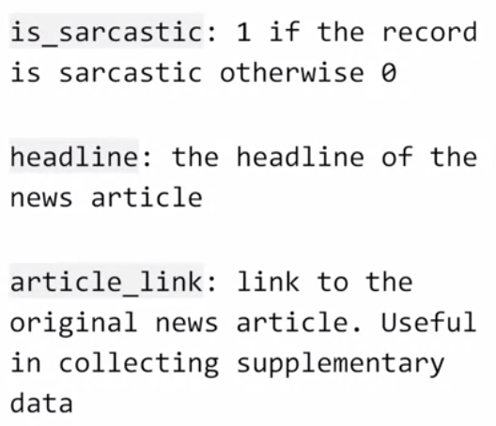

* The first is sarcastic, is our label. It's a one if the record is considered sarcastic otherwise it's zero.
* The second is a headline, which is just plain text and the third is the link to the article that the headline describes.
* Parsing the contents of HTML, stripping out scripts, and styles, etc, is a little bit beyond the scope of this course.
* So we're just going to focus on the headlines.
* If you download the data from that Kaggle site, you'll see something like this.

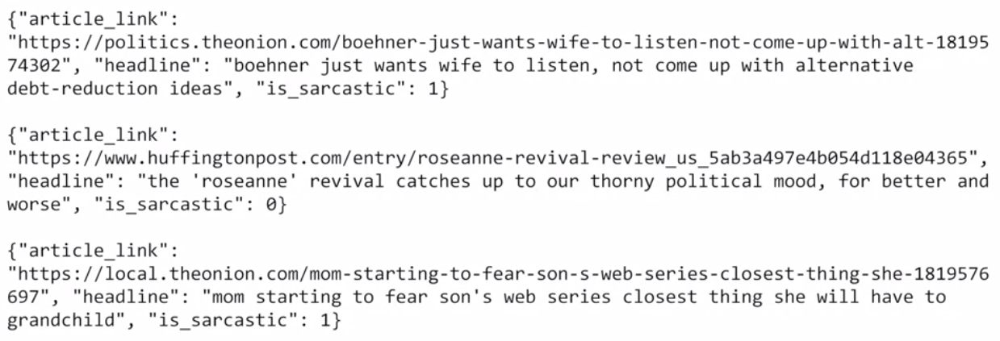

* As you can see, it is a set of list entries with name-value pairs where the name is article link, headline and is_sarcastic and the values are as shown.
* To make it much easier to load this data into Python, I made a little tweak to the data to look like this, which you can feel free to do or you can download my amended data-set from the link in the co-lab for this part of the course.

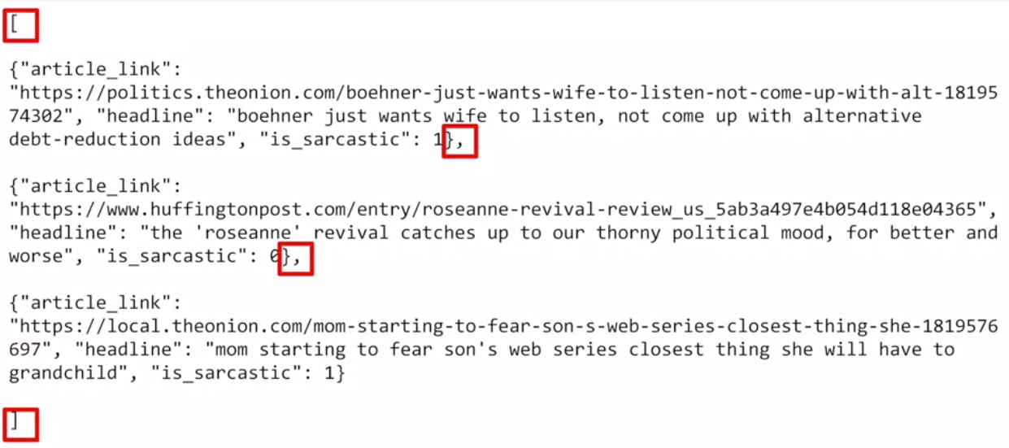

* Once you have the data like this, it's then really easy to load it into Python.
* Let's take a look at the code.

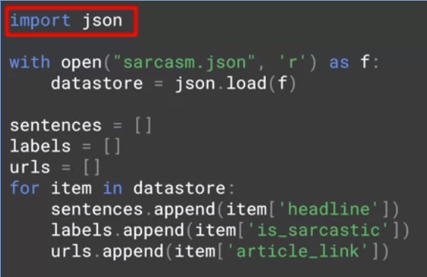

* So first you need to import JSON.
* This allows you to load data in JSON format and automatically create a Python data structure from it.
* To do that you simply open the file, and pass it to json.load and you'll get a list containing lists of the three types of data: headlines, URLs, and is_sarcastic labels.
* Because I want the sentences as a list of their own to pass to the tokenizer, I can then create a list of sentences and later, if I want the labels for creating a neural network,
* I can create a list of them too.
* While I'm at it, I may as well do URLs even though I'm not going to use them here but you might want to.
* Now I can iterate through the list that was created with a for item in data store loop.
* For each item, I can then copy the headline to my sentences, the is_sarcastic to my labels and the article_link to my URLs.
* Now I have something I can work with in the tokenizer, so let's look at that next.

#### Working with the Tokenizer

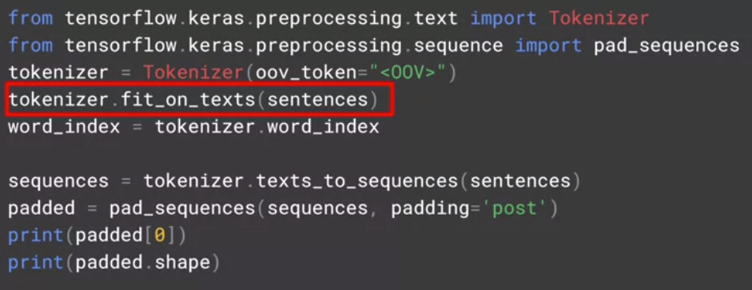

* We've just created sentences less from the headlines, in the sarcasm data set.
* So by calling tokenizer.fit_on_texts, will generate the word index and we'll initialize the tokenizer.
* We can see the word index as before by calling the word index property.
* Note that this returns all words that the tokenizer saw when tokenizing the sentences.
* If you specify num words to get the top 1000 or whatever, you may be confused by seeing something greater than that here.
* It's an easy mistake to make, but the key thing to remember, is that when it takes the top 1000 or whatever you specified, it does that in the texts_to_sequences this process.
* Our word index is much larger than with the previous example.
* So we'll see a greater variety of words in it. Here's a few.

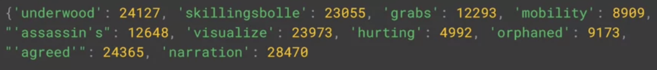

* Now we'll create the sequences from the text, as well as padding them.

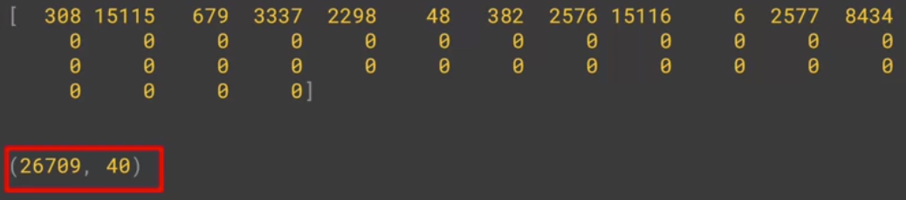

* First, I took the first headline in the data set and showed its output.
* We can see that it has been encoded with the values for the keys that are the corresponding word in the sentence.
* This is the size of the padded matrix.
* We had 26,709 sentences, and they were encoded with padding, to get them up to 40 words long which was the length of the longest word.
* You could truncate this if you like, but I'll keep it at 40.
* That's it for processing the Sarcasm data set.

## News headlines dataset for sarcasm detection

The following is the public domain dataset based on sarcasm, as depicted in the previous video.

The link is provided here for your convenience:

[**Sarcasm in News Headlines Dataset by Rishabh Misra**](https://rishabhmisra.github.io/publications/)

## Check out the code!

Let's take a look at the third [notebook](https://colab.research.google.com/github/lmoroney/dlaicourse/blob/master/TensorFlow%20In%20Practice/Course%203%20-%20NLP/Course%203%20-%20Week%201%20-%20Lesson%203.ipynb).

#### Introduction to Embedding

* Last week, you looked at tokenizing text. Where you turned text into sequences of numbers with a number was the value of a key value pair with the key being the word.
* So for example, you could represent the word TensorFlow with the value nine, and then replace every instance of the word with a nine in a sequence.
* Using tools and TensorFlow, you are able to process strings to get indices of all the words in a corpus of strings and then convert the strings into matrices of numbers.
* This is the start of getting sentiment out of your sentences.
* But right now, it's still just a string of numbers representing words.
* So from there, how would one actually get sentiment?
* *Well, that's something that can be learned from a corpus of words in much the same way as features were extracted from images.*
* *This process is called* ***embedding****, with the idea being that words and associated words are clustered as vectors in a multi-dimensional space.*
* Here, I'm showing an embedding projector with classifications of movie reviews.

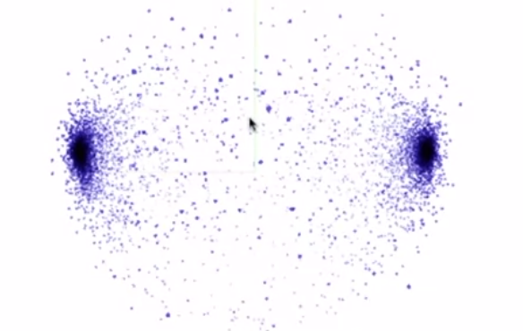

* The reviews are in two main categories; positive and negative.
* So together with the labels, TensorFlow was able to build these embeddings showing a clear clustering of words that are distinct to both of these review types.
* I can actually search for words to see which ones match a classification.
* So for example, if I search for boring, we can see that it lights up in one of the clusters and that associated words were clearly negative such as unwatchable.

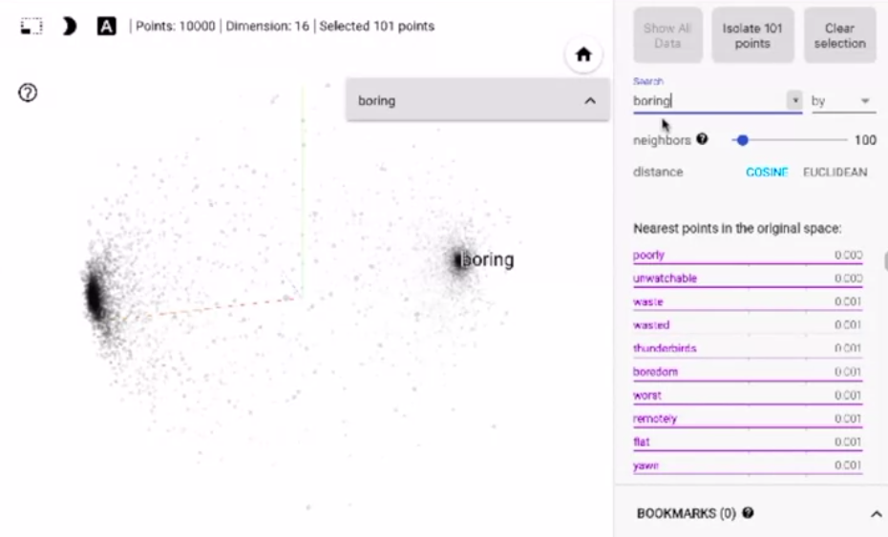

* Similarly, if I search for a negative word like annoying, I'll find it along with annoyingly in the cluster that's clearly the negative reviews.
* Or if I search for fun,
* I'll find that fun and funny are positive, fundamental is neutral, and unfunny is of course, negative.

#### The IMBD dataset

* Part of the vision of TensorFlow to make machine learning and deep learning easier to learn and easier to use, is the concept of having built-in data sets.
* You seen the little bit of a preview of the way back in the first course, when the fashion MNEs was available to you without you needing to download and split the data into training a test sets. d
* Expanding on this, there's a library called TensorFlow Data Services or TFTS for short, and that contains many data sets and lots of different categories.

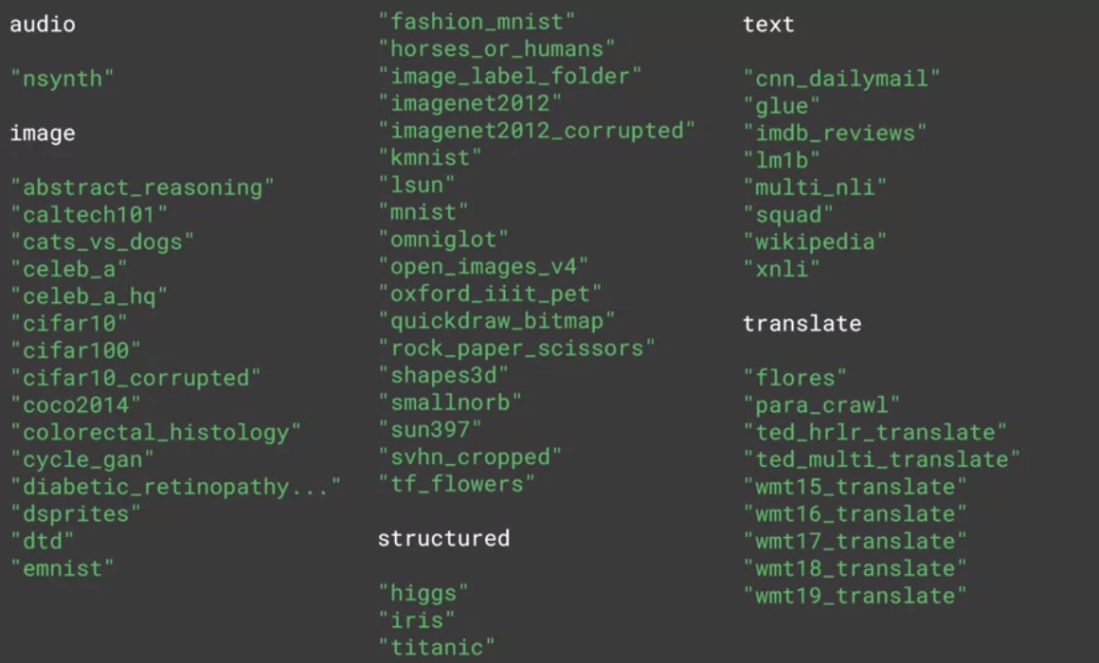

* Here are some examples; and while we can see that there are many different data sets for different types, particularly image-based, there's also a few for text, and we'll be using the IMDB reviews dataset next.
* This dataset is ideal because it contains a large body of texts, 50,000 movie reviews which are categorized as positive or negative.
* It was authored by Andrew Mass et al at Stanford, and you can learn more about it at this link.



## IMDB reviews dataset

Please find the link to he IMDB reviews dataset [here](http://ai.stanford.edu/~amaas/data/sentiment/)

#### Looking into the details

* Check for the tensorflow version, if the code gave you TensorFlow 1.x, you'll need to enable eager execution (**tf.enable_eager_execution**) before you can go any further.
* If it gave you 2.x, then you won't need anything because eager execution is enabled by default in TensorFlow 2.0.
* If you're using Google Colab, then you should have TensorFlow datasets already installed.
* Should you not have them, they're easily installed with this line of code.

**!pip install –q tensorflow-datasets**

* Now, you can import TensorFlow datasets, and in this case I call them tfds.



* With imdb reviews, I can now call tfds.load, pass it the string imdb reviews, and it will return the data from imdb, and metadata about it with this code.

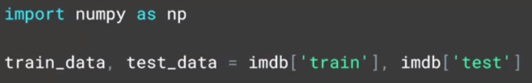

* The data is split into 25,000 samples for training and 25,000 samples for testing.
* Each of these are iterables containing the 25,000 respective sentences and labels as tensors.
* Up to this point, we've been using the kera's tokenizers and padding tools on arrays of sentences, so we need to do a little converting.

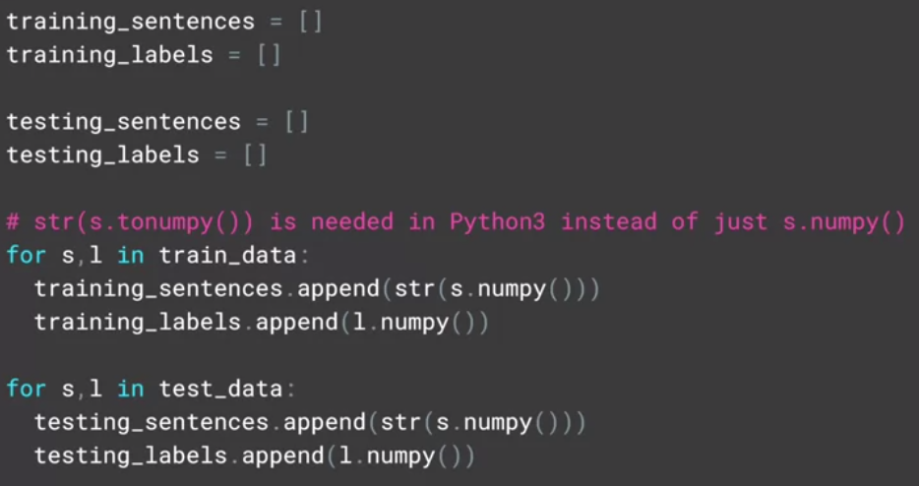

* First of all, let's define the lists containing the sentences and labels for both training and testing data. Now, I can iterate over training data extracting the sentences and the labels.
* The values for S and I are tensors, so by calling their NumPy method, I'll actually extract their value.
* Then I'll do the same for the test set.
* Here's an example of a review. I've truncated it to fit it on this slide, but you can see how it is stored as a tf.tensor.

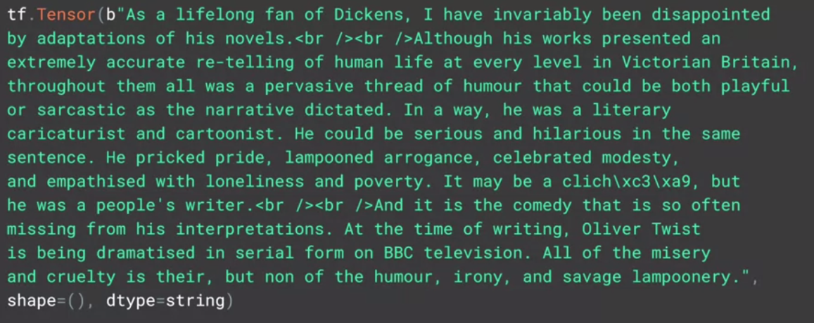

* Similarly, here's a bunch of labels also stored as tensors.

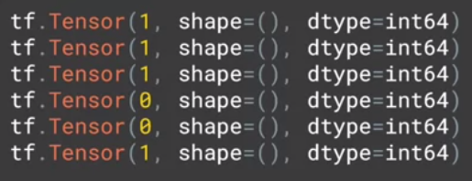

* The value 1 indicates a positive review and zero a negative one.
* When training, my labels are expected to be NumPy arrays.

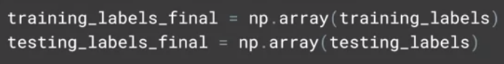

* So I'll turn the list of labels that I've just created into NumPy arrays with this code.
* Next up, we'll tokenize our sentences. Here's the code.

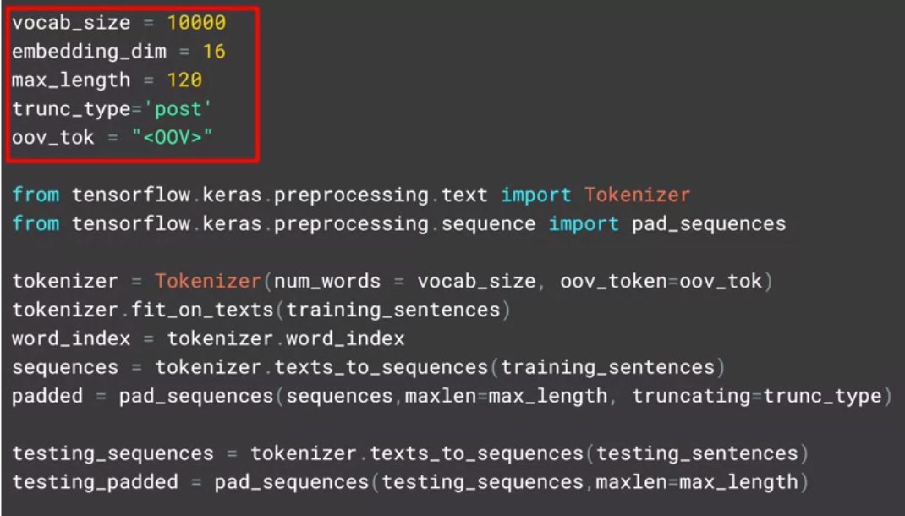

* I've put the hyperparameters at the top like this for the reason that it makes it easier to change and edit them, instead of phishing through function sequences for the literals and then changing those. Now, as before, we import the tokenizer and the pad sequences. We'll create an instance of tokenizer, giving it our vocab size and our desired out of vocabulary token. We'll now fit the tokenizer on our training set of data. Once we have our word index, we can now replace the strings containing the words with the token value we created for them. This will be the list called sequences. As before, the sentences will have variant length. So we'll pad and or truncate the sequenced sentences until they're all the same length, determined by the maxlength parameter. Then we'll do the same for the testing sequences.
* Note that the word index is words that are derived from the training set, so you should expect to see a lot more out of vocabulary tokens in the test exam.
* Now it's time to define our neural network.

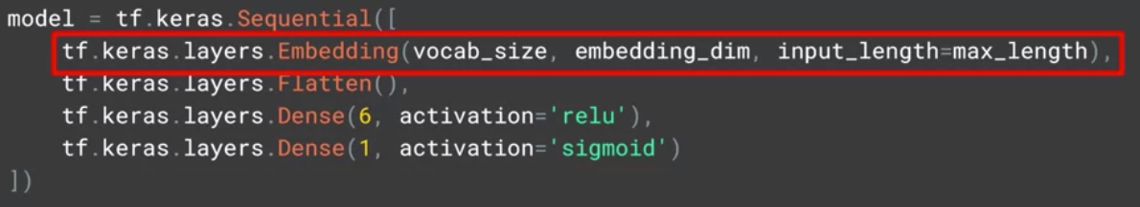

* This should look very familiar by now, except for maybe this line, the embedding.
* This is the key to text sentiment analysis in TensorFlow, and this is where the magic really happens.

#### How can we use vectors?

* The full scope of how embeddings work is beyond the scope of this course.
* But think of it like this.
* You have words in a sentence and often words that have similar meanings are close to each other.
* So in a movie review, it might say that the movie was dull and boring, or it might say that it was fun and exciting.
* So what if you could pick a vector in a higher-dimensional space say 16 dimensions, and words that are found together are given similar vectors.
* Then over time, words can begin to cluster together.
* The meaning of the words can come from the labelling of the dataset.
* So in this case, we say a negative review and the words dull and boring show up a lot in the negative review so that they have similar sentiments, and they are close to each other in the sentence.
* Thus their vectors will be similar.
* As the neural network trains, it can then learn these vectors associating them with the labels to come up with what's called an embedding i.e., the vectors for each word with their associated sentiment.
* The results of the embedding will be a 2D array with the length of the sentence and the embedding dimension for example 16 as its size.

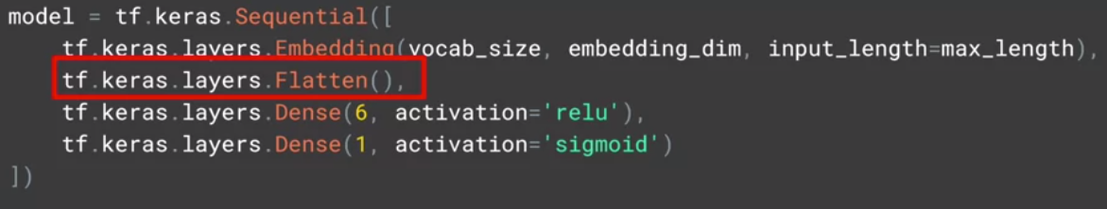

* So we need to flatten it out in much the same way as we needed to flatten out our images.
* We then feed that into a dense neural network to do the classification.
* Often in natural language processing, a different layer type than a flatten is used, and this is a global average pooling 1D.

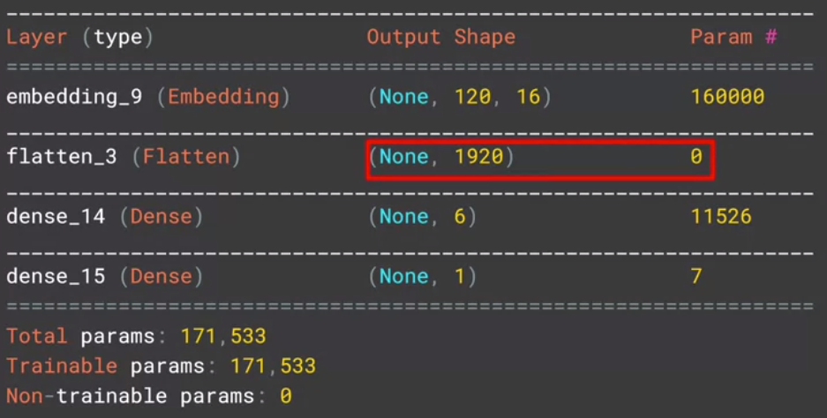

* The reason for this is the size of the output vector being fed into the dense.
* So for example, if I show the summary of the model with the flatten that we just saw, it will look like this.

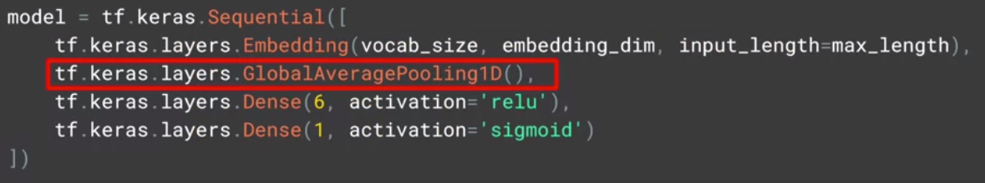

* Or alternatively, you can use a Global Average Pooling 1D like this, which averages across the vector to flatten it out.
* Your model summary should look like this, which is simpler and should be a little faster.

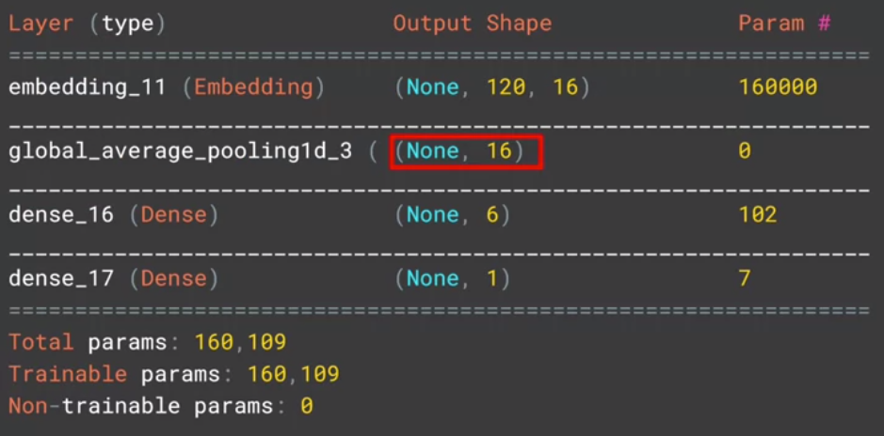

* Try it for yourself in colab and check the results.

#### More into the details



* You can compile your model as before, and print out the summary with this code.
* Now training is the simplest passing padded and your training_labels_final as your training set, specifying the number of epochs, and passing the testing_padded and testing_labels_final as your test set.

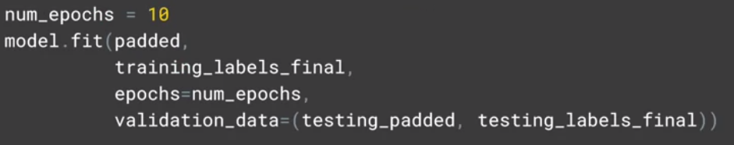

* Here's the results of training, with the training set giving us 1.00 accuracy and the validation set at 0.8259.

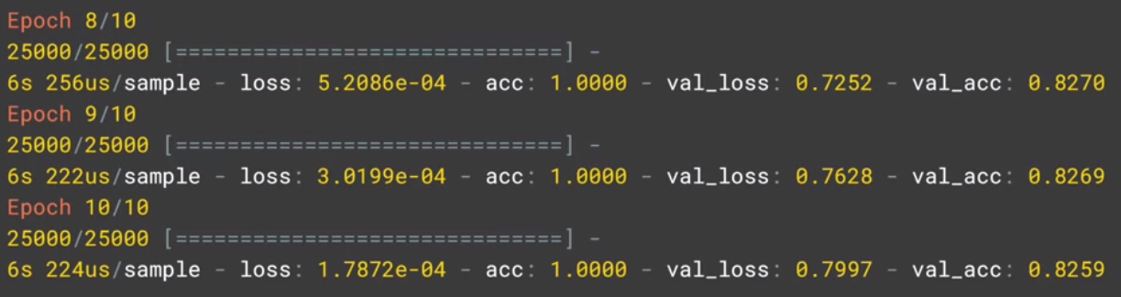

* So there's a good chance that we're overfitting.
* We'll look at some strategies to avoid this later, but you should expect results a little bit like this.
* Okay. Now we need to talk about and demonstrate the embeddings, so you can visualize them like you did right back at the beginning of this lesson.

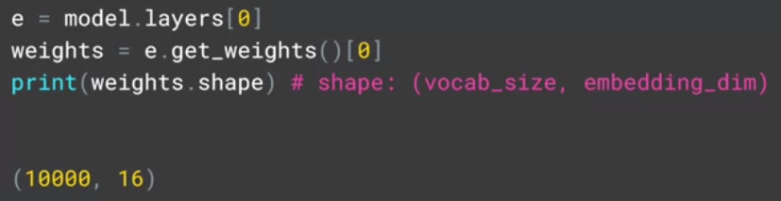

* We'll start by getting the results of the embeddings layer, which is layer zero. We can get the weights, and print out their shape like this.
* We can see that this is a 10,000 by 16 array, we have 10,000 words in our corpus, and we're working in a 16 dimensional array, so our embedding will have that shape.
* To be able to plot it, we need a helper function to reverse our word index.

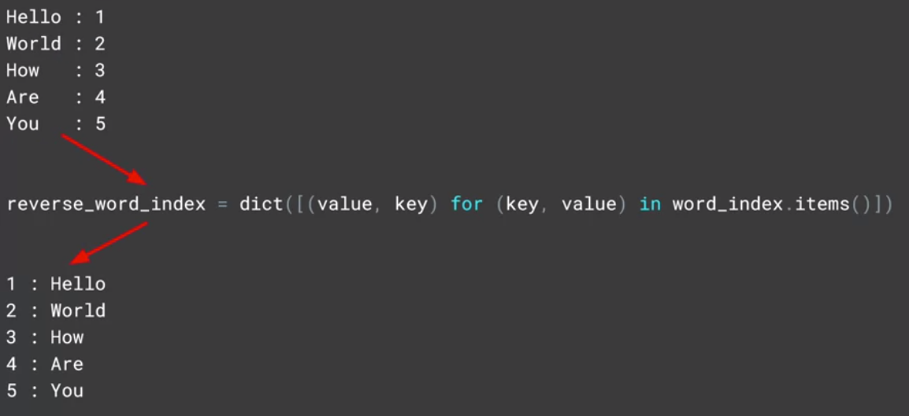

* As it currently stands, our word index has the key being the word, and the value being the token for the word.
* We'll need to flip this around, to look through the padded list to decode the tokens back into the words, so we've written this helper function.
* Now it's time to write the vectors and their metadata auto files.

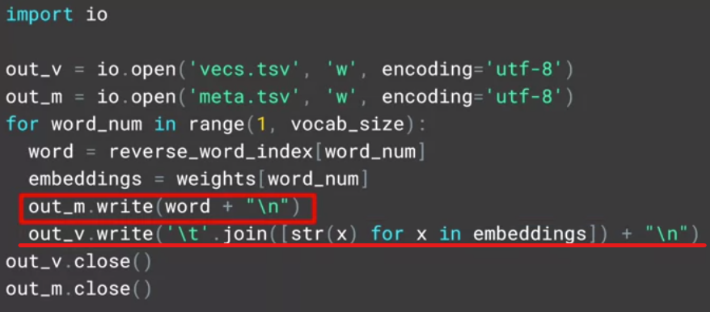

* The TensorFlow Projector reads this file type and uses it to plot the vectors in 3D space so we can visualize them.
* To the vectors file, we simply write out the value of each of the items in the array of embeddings, i.e, the co-efficient of each dimension on the vector for this word.
* To the metadata array, we just write out the words.

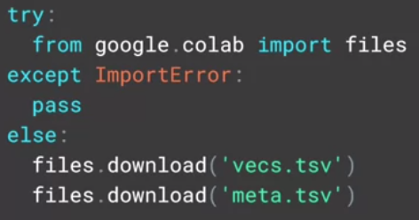

* If you're working in Colab, this code will download the two files.
* To now render the results, go to the TensorFlow Embedding Projector on projector.tensorflow.org , press the ''Load data'' button on the left.
* You'll see a dialog asking you to load data from your computer.
* Use vector.TSV for the first one, and meta.TSV for the second.
* Once they're loaded, you should see something like this.

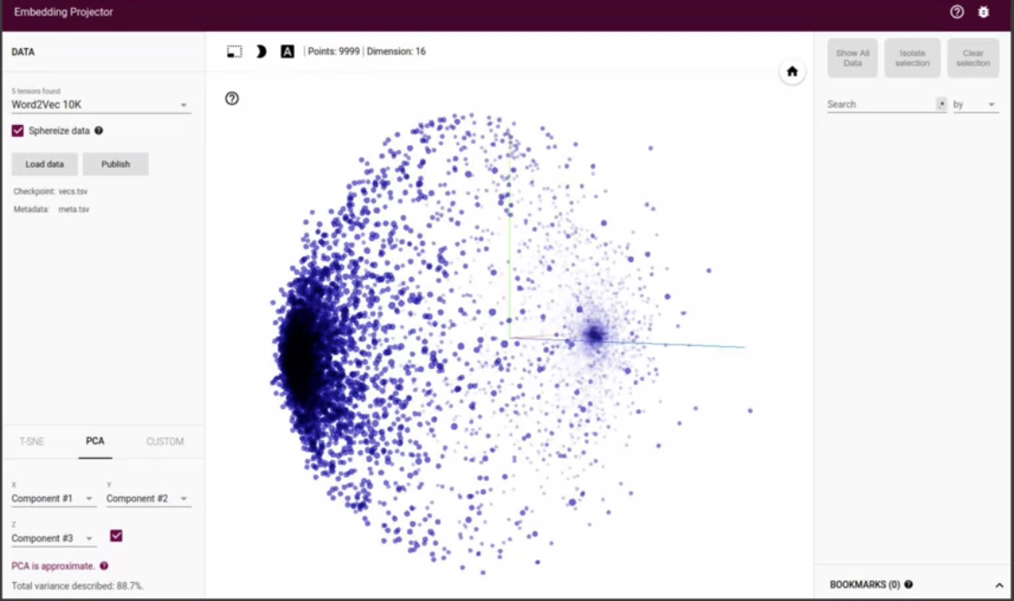

* Click this ''sphereize data'' checkbox on the top left, and you'll see the binary clustering of the data.
* Experiment by searching for words, or clicking on the blue dots in the chart that represent words.
* Above all, have some fun with it.

## Check out the code!

Let's take a look at the first [notebook](https://colab.research.google.com/github/lmoroney/dlaicourse/blob/master/TensorFlow%20In%20Practice/Course%203%20-%20NLP/Course%203%20-%20Week%202%20-%20Lesson%201.ipynb).

#### Remember the sarcasm dataset?

* So that was an example using the IMDB data set, where data is provided to you by the tfds API, which I hope you found helpful.
* Now I'd like to return to the sarcasm data set from last week, and let's look at building a classifier for that.
* We'll start with importing tensorflow and json, as well as the tokenizer and pad sequences from pre-processing.

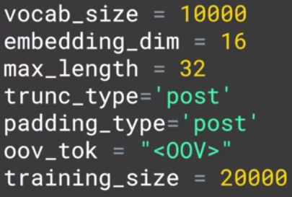

* Now let's set up our hyper parameters; the vocabulary size, embedding dimensions, maximum length of sentences, and other stuff like the training size.
* This data set has about 27,000 records.
* So let's train on 20,000 and validate on the rest.
* The sarcasm data is stored at this URL, so you can download.

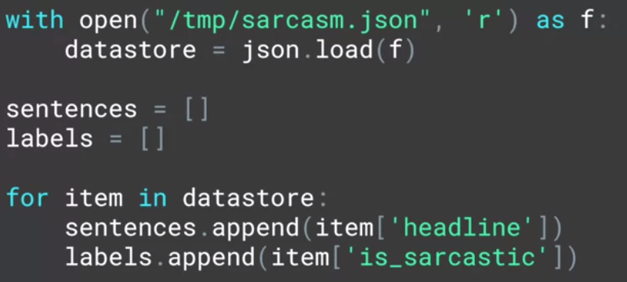

* Now that you have the data set, you can open it and load it as an iterable with this code.
* You can create an array for sentences, and another for labels, and then iterate through the datastore, loading each headline as a sentence, and each is_sarcastic field, as your label.

#### Building a classifier for the sarcasm dataset

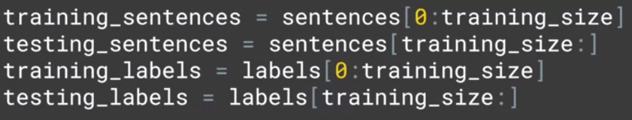

* To split the corpus into training and validation sets, we'll use this code.
* To get the training set, you take array items from zero to the training size, and to get the testing set, you can go from training size to the end of the array with code like this.
* To get the training and testing labels, you'll use similar codes to slice the labels array.
* Now that we have training and test sets of sequences and labels, it's time to sequence them.

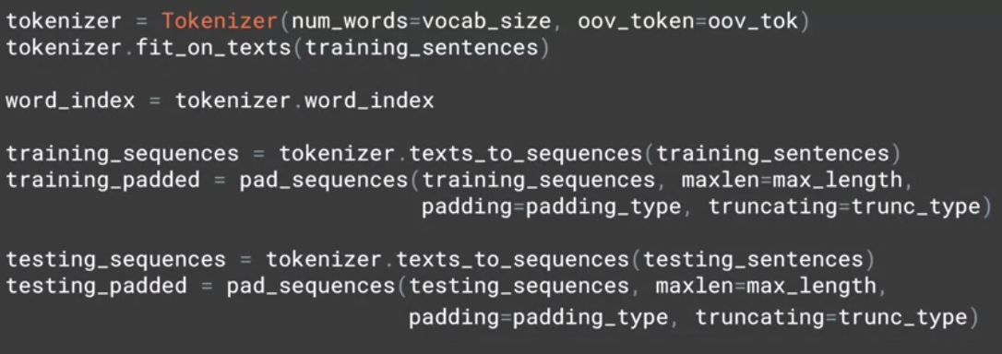

* To pad those sequences, you'll do that with this code.
* You start with a tokenizer, passing it the number of words you want to tokenize on and the desired out of vocabulary token.
* Then fit that on the training set by calling fit on texts, passing it the training sentences array.
* Then you can use text to sequences to create the training sequence, replacing the words with their tokens.
* Then you can pad the training sequences to the desired length or truncate if they're too long.
* Next, you'll do the same but with a test set.
* Now, we can create our neural network in the usual way. We'll compile it with binary cross entropy, as we're classifying to different classes.

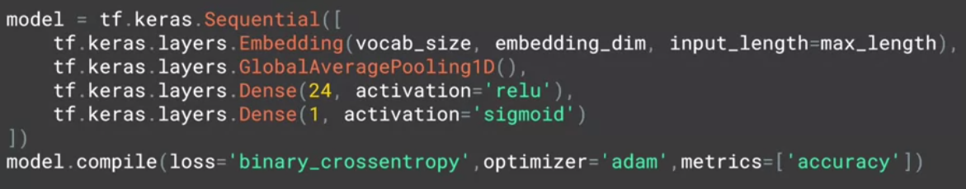

* When we call a model's summary, we'll see that it looks like this, pretty much as we'd expect.

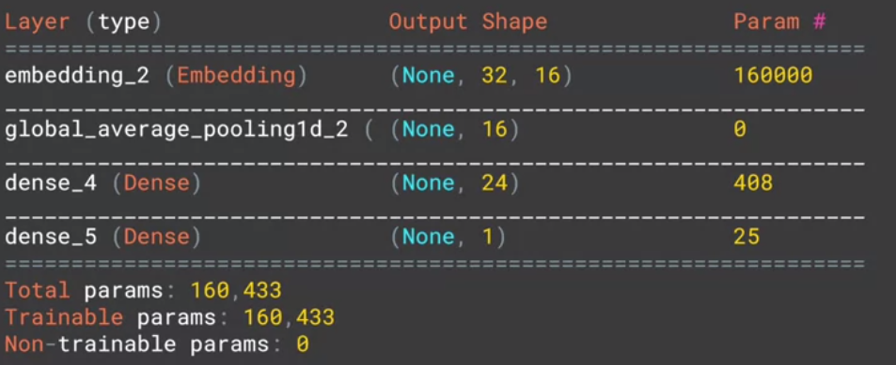

* It's pretty simple and embedding feeds into an average pooling, which then feeds our DNN.
* To train for 30 epochs, you pass in the padded data and labels.

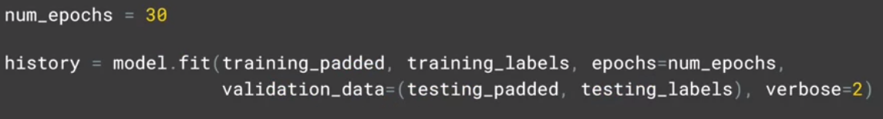

* If you want to validate, you'll give the testing padded and labels to.
* After training for little while, you can plot the results.
* Here's the code for simple plot.

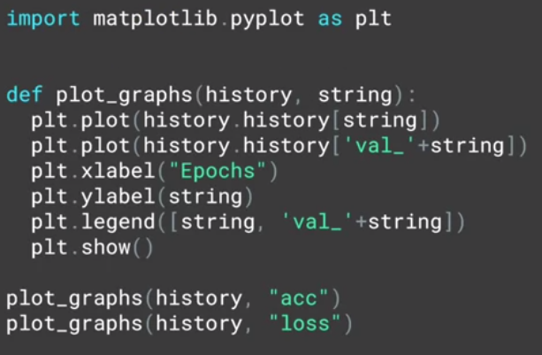

* We can see accuracy increase nicely as we trained and the validation accuracy was okay, but not great.
* What's interesting is the loss values on the right, the training loss fall, but the validation loss increased. Well, why might that be?

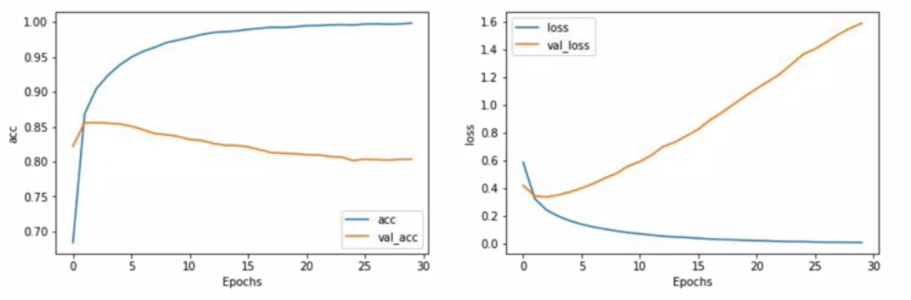

Note: The purpose of embedding dimension is the number of dimensions for the vector representing the word encoding.

#### Let’s talk about the loss function

* Think about loss in this context, as a confidence in the prediction.
* So while the number of accurate predictions increased over time, what was interesting was that the confidence per prediction effectively decreased.
* You may find this happening a lot with text data.
* So it's very important to keep an eye on it.
* One way to do this is to explore the differences as you tweak the hyperparameters.

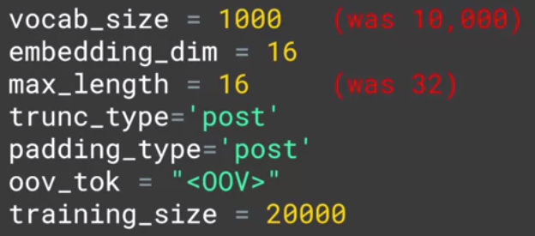

* So for example, if you consider these changes, a decrease in vocabulary size, and taking shorter sentences, reducing the likelihood of padding, and then rerun, you may see results like this.

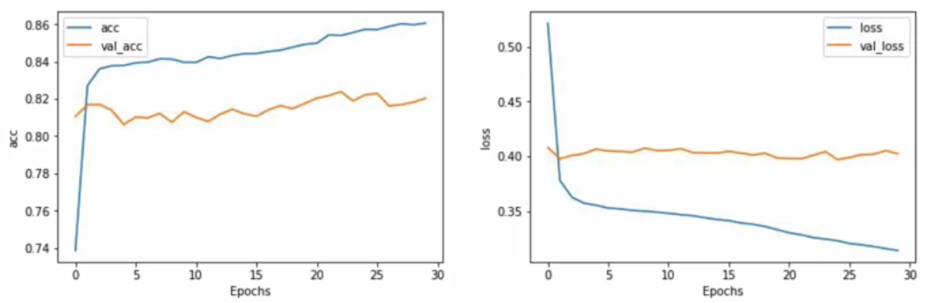

* Here, you can see that the loss has flattened out which looks good, but of course, your accuracy is not as high.
* Another tweak. Changing the number of dimensions using the embedding was also tried.
* Here, we can see that that had very little difference.

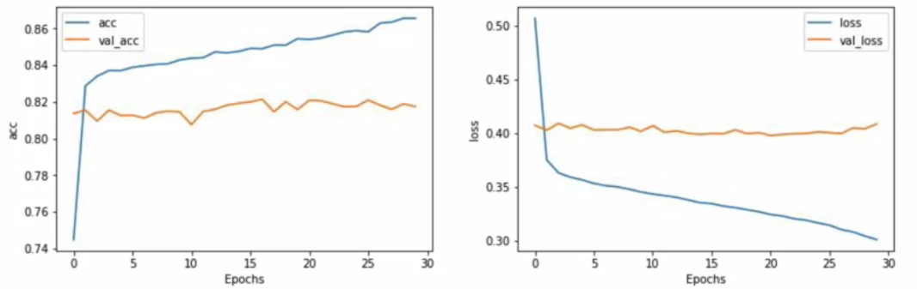

* Putting the hyperparameters as separate variables like this is a useful programming exercise, making it much easier for you to tweak and explore their impact on training.
* Keep working on them and see if you can find any combinations that give a 90 percent plus training accuracy without a cost of the lost function increasing sharply.

## Check out the code!

Let's take a look at the second [notebook](https://colab.research.google.com/github/lmoroney/dlaicourse/blob/master/TensorFlow%20In%20Practice/Course%203%20-%20NLP/Course%203%20-%20Week%202%20-%20Lesson%202.ipynb) .

#### Pre-tokenized datasets

* Earlier, we looked at using TensorFlow Data Services, or TFDS to load the reviews from the IMDB dataset and perform classification on them.
* You loaded the raw text for the reviews, and tokenized them yourself.
* However, often with prepackaged datasets like these, some data scientists have done the work for you already, and the IMDB dataset is no exception.
* Next, we'll take a look at a version of the IMDB dataset that has been pre-tokenized for you, but the tokenization is done on sub words.
* We'll use that to demonstrate how text classification can have some unique issues, namely that the sequence of words can be just as important as their existence.

## TensorFlow datasets

Please find [here](https://github.com/tensorflow/datasets/tree/master/docs/catalog) the datasets GitHub url.

For more information, please checkout the [TensorFlow datasets documentation](https://www.tensorflow.org/datasets/catalog/overview).

#### Diving into the code (part 1)

* So we'll start by looking at TensorFlow data-sets.
* If you look at the IMDB reviews data-set, you'll see that there's a bunch of versions that you can use.
* These include,"plain_text" which we used in the last video,"bytes", where the text is encoded at byte level, and sub-word encoding which we'll look at it now.
* One thing to note is that you should use TensorFlow 2.0 to for the code I'll be sharing here.



* Once you're on TensorFlow 2, you can now start using the imdb subwords data-set.
* We'll use the 8k version for now.



* Getting access to your training and test data is then as easy as this.

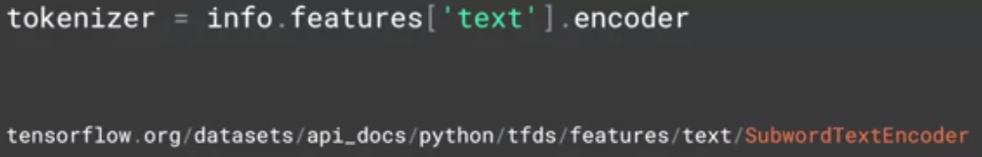

* Next, if you want to access the sub words tokenizer, you can do it with this code.
* You can learn all about the sub-words texts encoder at this URL.

#### Diving into the code (part 2)

* We have a pre-trained sub-words tokenizer now, so we can inspect its vocabulary by looking at its sub-words property.

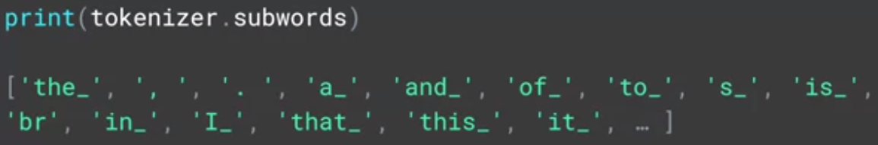

* If we want to see how it encodes or decode strings, we can do so with this code.

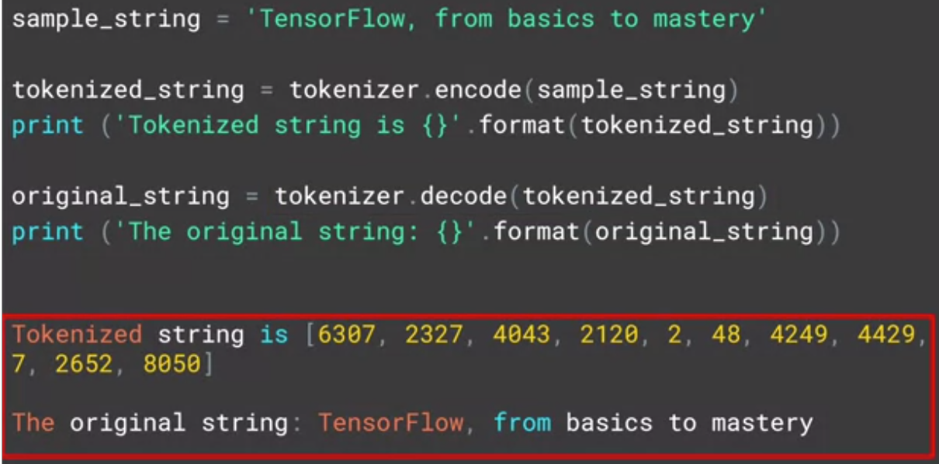

* So we can encode simply by calling the encode method passing it the string.
* Similarly, decode by calling the decode method.
* We can see the results of the tokenization when we print out the encoded and decoded strings.
* If we want to see the tokens themselves, we can take each element and decode that, showing the value to token.

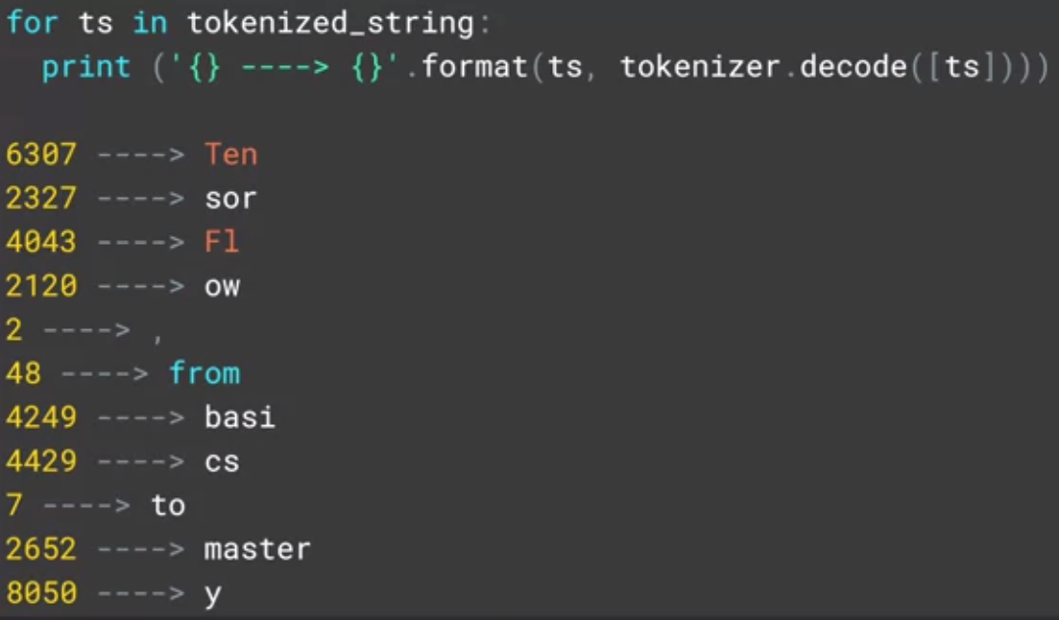

* Note that this is case sensitive and punctuation is maintained unlike the tokenizer.
* You don't need to do anything with them yet, I just wanted to show you how sub-word tokenization works.
* So now, let's take a look at classifying IMDB with it. What the results are going to be?
* Here's the model. Again, it should look very familiar at this point.

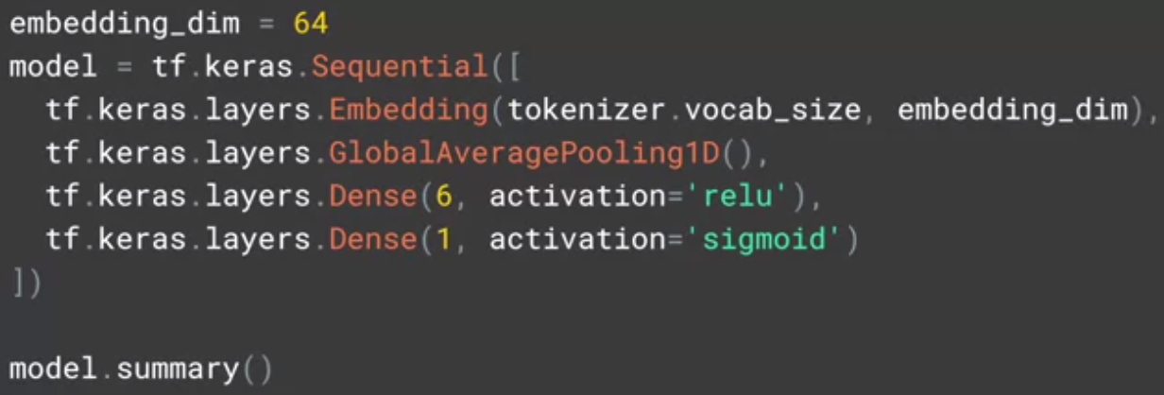

* One thing to take into account though, is the shape of the vectors coming from the tokenizer through the embedding, and it's not easily flattened.
* So we'll use Global Average Pooling 1D instead.
* Trying to flatten them, will cause a TensorFlow crash.
* Here's the output of the model summary.

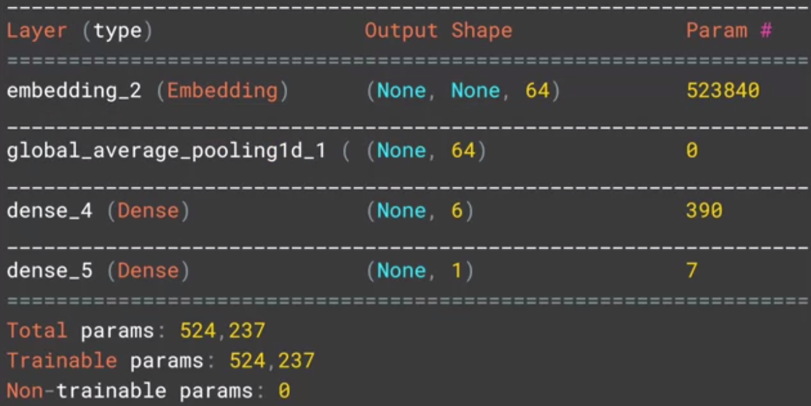

* You can compile and train the model like this, it's pretty standard code.

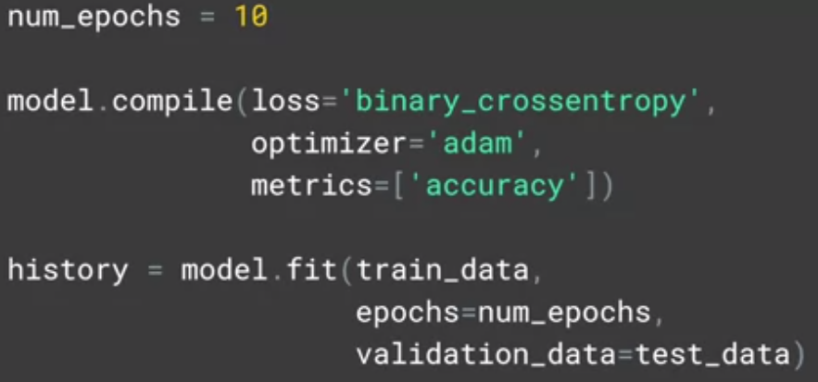

* Training is dealing with a lot of hyper-parameters and sub-words, so expect it to be slow.
* If your results don't look good, don't worry, that's part of the point.
* You can graph the results with this code, and your graphs will probably look something like this.

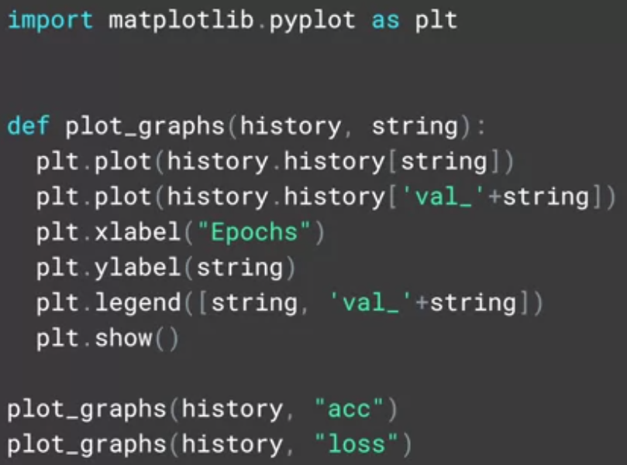

* In my case, the accuracy was barely about 50 percent, which you could get with a random guess.

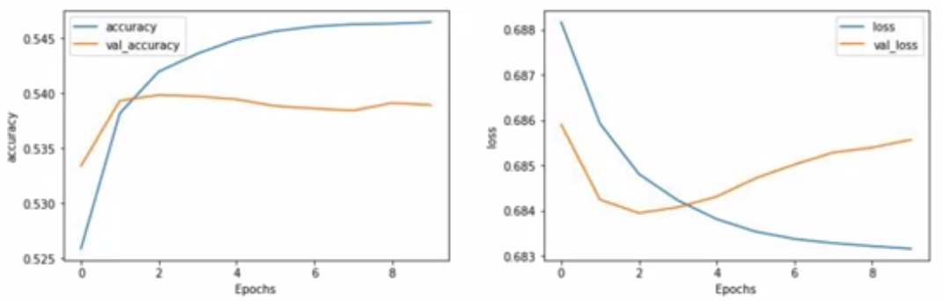

* While losses decreasing, it's decreasing in a very small way.
* So why do you think that might be?
* Well, the keys in the fact that we're using sub-words and not for-words, sub-word meanings are often nonsensical and it's only when we put them together in sequences that they have meaningful semantics.
* Thus, some way from learning from sequences would be a great way forward, and that's exactly what you're going to do next with recurrent neural networks

## Check out the code!

Let's take a look at the third [notebook](https://colab.research.google.com/github/lmoroney/dlaicourse/blob/master/TensorFlow%20In%20Practice/Course%203%20-%20NLP/Course%203%20-%20Week%202%20-%20Lesson%203.ipynb).

#### Introduction to Recurrent Neural Network (RNN)

* Earlier, we looked at doing classification using texts and trying to train and understand positive and negative sentiment in movie reviews.
* *We finished by looking at the effect of tokenizing words, and saw that our classifier failed to get any meaningful results.*
* *The main reason for this was that the context of words was hard to follow when the words were broken down into sub-words and the sequence in which the tokens for the sub-words appear becomes very important in understanding their meaning.*
* Let's take a look at that now.

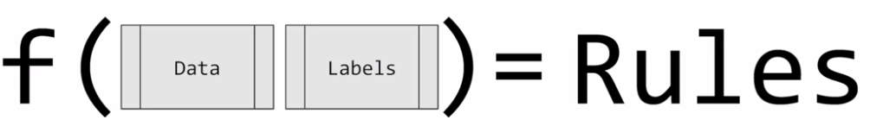

* The neural network is like a function that when you feed it in data and labels, it infers the rules from these, and then you can use those rules.
* So it could be seen as a function a little bit like this, you take the data and you take the labels, and you get the rules.
* But this doesn't take any kind of sequence into account.
* To understand why sequences can be important, consider this set of numbers.

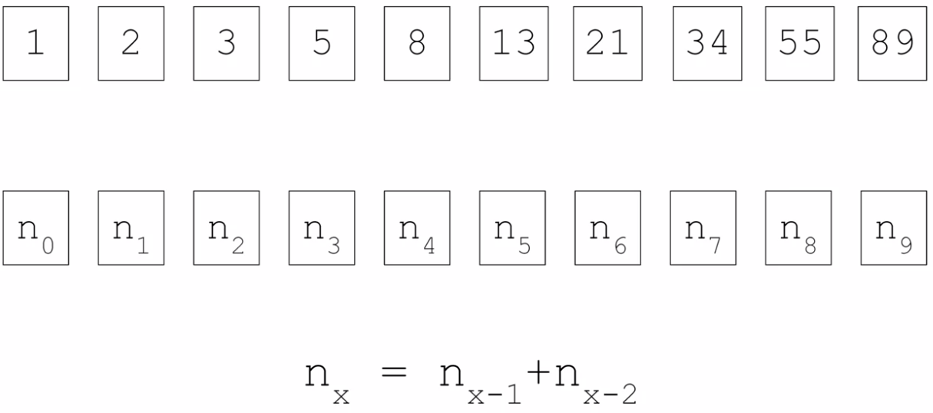

* If you've never seen them before, they're called the Fibonacci sequence.
* So let's replace the actual values with variables such as n_0, n_1 and n_2, etc., to denote them.
* Then the sequence itself can be derived where a number is the sum of the two numbers before it.
* So 3 is 2 plus 1, 5 is 2 plus 3, 8 is 3 plus 5, etc.
* Our n_x equals n_x minus 1, plus n_x minus 2, where x is the position in the sequence.

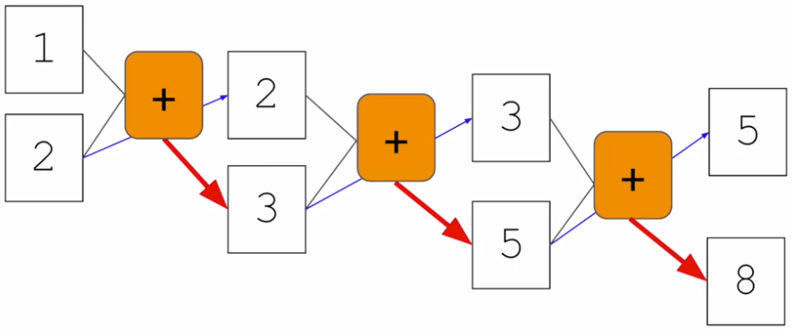

* Visualized, it might also look like this, one and two feed into the first function and three comes out. Two gets carried over to the next, where it's fed in along with the three to give us a five. The three is carried on to the next where it's fed into the function along with the five to get an eight and so on.
* *This is similar to the basic idea of a recurrent neural network or RNN, which is often drawn a little like this.*

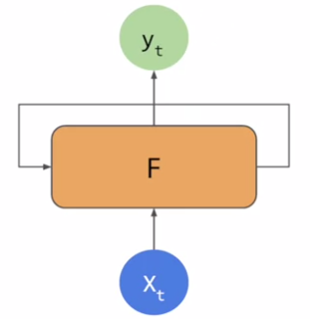

* You have your x as in input and your y as an output.
* But there's also an element that's fed into the function from a previous function.

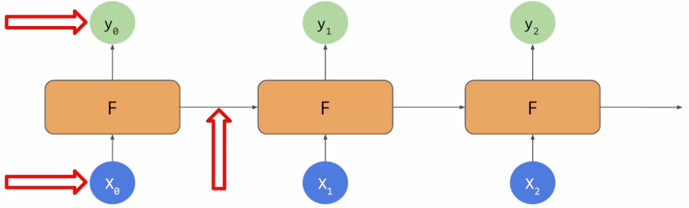

* That becomes a little clearer when you chain them together like this, x_0 is fed into the function returning y_0.
* An output from the function is then fed into the next function, which gets fed into the function along with x_2 to get y_2, producing an output and continuing the sequence.
* As you can see, there's an element of x_0 fed all the way through the network, similar with x_1 and x_2 etc.
* This forms the basis of the recurrent neural network or RNN.

## Link to Andrew's sequence modeling course

Here is the [link](https://www.coursera.org/lecture/nlp-sequence-models/deep-rnns-ehs0S) to Andrew's course on sequence modeling.

#### LSTMs

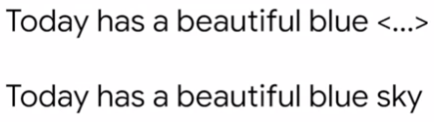

* There can be a limitation when approaching text classification in this way.
* Consider the following. Here's a sentence.
* **Today has a beautiful blue** <..>.
* What do you think would come next? Probably sky. Right?
* **Today has a beautiful blue sky.**
* Why would you say that?
* Well, there's a big clue in the word blue. In a context like this, it's quite likely that when we're talking about a beautiful blue something, we mean a beautiful blue sky.
* So, the context word that helps us understand the next word is very close to the word that we're interested in.
* But, what about a sentence like this, **I lived in Ireland so at school they made me learn how to speak** <..>.
* How would you finish that sentence?
* Well, you might say Irish but you'd be much more accurate if you said, **I lived in Ireland so at school they made me learn how to speak Gaelic.**
* First of course, is the syntactic issue!
* Irish describes the people, Gaelic describes the language.
* But more importantly in the ML context is the key word that gives us the details about the language.
* That's the word **Ireland**, which appears much earlier in the sentence.
* So, if we're looking at a sequence of words we might lose that context.
* *With that in mind an update to RNNs is called* ***LSTM, long short - term memory*** *has been created.*

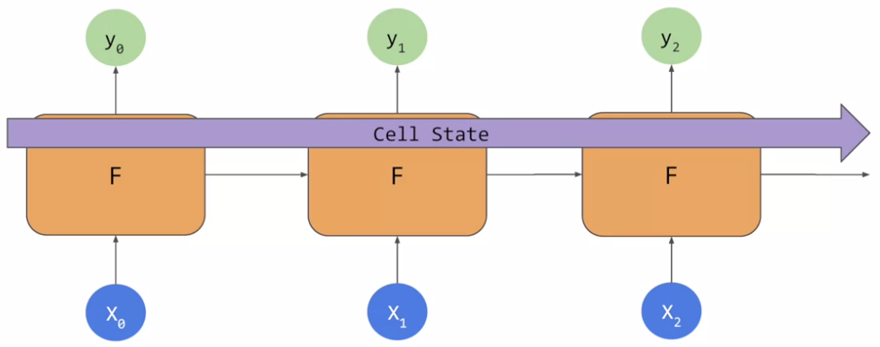

* *In addition to the context being passed as it is in RNNs, LSTMs have an additional pipeline of contexts called cell state.*
* This can pass through the network to impact it.
* This helps keep context from earlier tokens relevance in later ones so issues like the one that we just discussed can be avoided.
* Cell states can also be bidirectional.

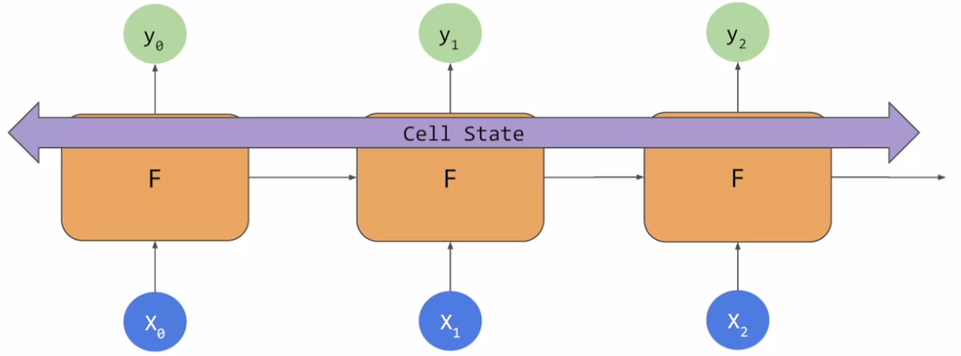

* So later contexts can impact earlier ones as we'll see when we look at the code.

## More info on LSTMs

Please find here a [link](https://www.coursera.org/lecture/nlp-sequence-models/long-short-term-memory-lstm-KXoay) to more information on LSTMs (Long Short Term Memory cells) by Andrew.

#### Implementing LSTMs in code

* So let's now take a look at how to implement LSTMs in code.

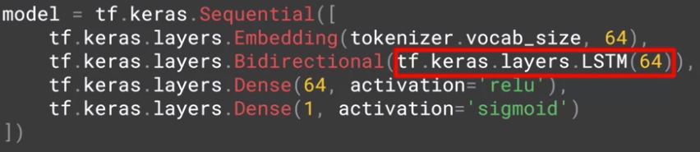

* Here's my model where I've added the second layer as an LSTM.
* I use the **tf.keras.layers.LSTM** to do so.
* The parameter passed in is the number of outputs that I desire from that layer, in this case it's 64.
* If I wrap that with **tf.keras.layers.Bidirectional**, it will make my cell state go in both directions.
* You'll see this when you explore the model summary, which looks like this.

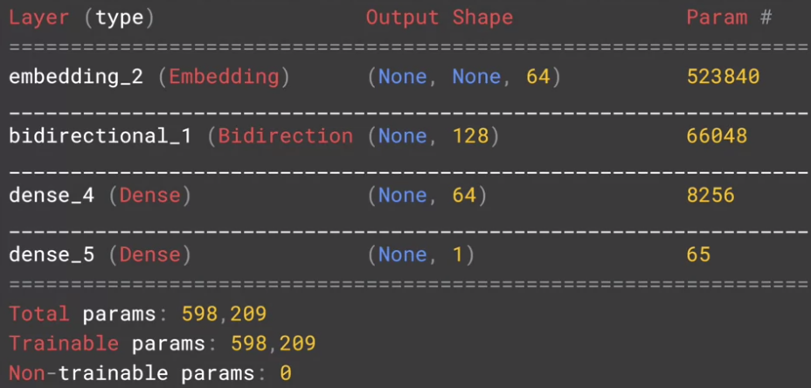

* We have our embedding and our bidirectional containing the LSTM, followed by the two dense layers.
* If you notice the output from the bidirectional is now a 128, even though we told our LSTM that we wanted 64, the bidirectional doubles this up to a 128.
* You can also stack LSTMs like any other keras layer by using code like this.

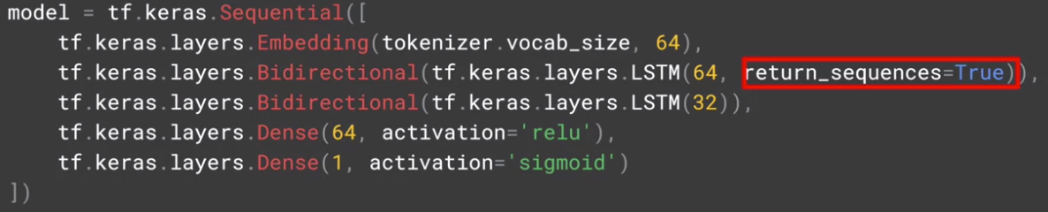

* *But when you feed an LSTM into another one, you do have to put the return sequences equal true parameter into the first one.*
* *This ensures that the outputs of the LSTM match the desired inputs of the next one.*
* The summary of the model will look like this.

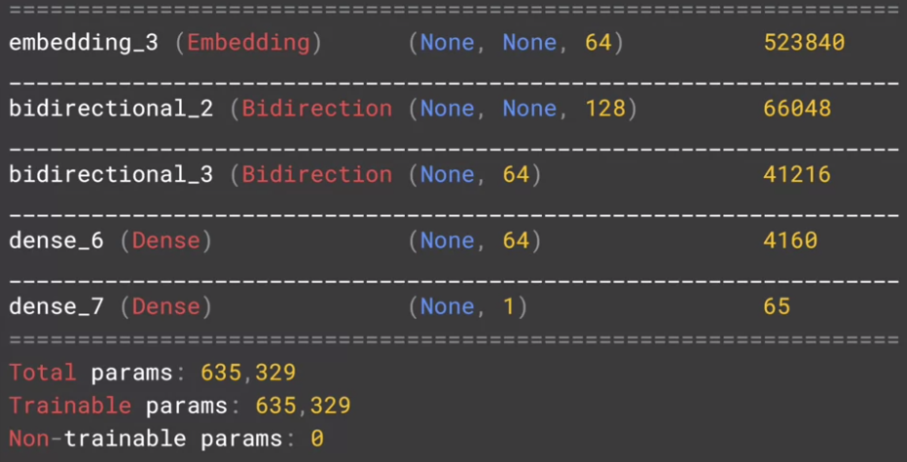

* Let's look at the impact of using an LSTM on the model that we looked at in the last module, where we had sub word tokens.

## Check out the code!

We've created a number of notebooks for you to explore the different types of sequence models.

Spend some time going through these to see how they work, and what the impact of different layer types have on training for classification.

[IMDB Subwords 8K with Single Layer LSTM](https://colab.research.google.com/github/lmoroney/dlaicourse/blob/master/TensorFlow%20In%20Practice/Course%203%20-%20NLP/Course%203%20-%20Week%203%20-%20Lesson%201a.ipynb)

[IMDB Subwords 8K with Multi Layer LSTM](https://colab.research.google.com/github/lmoroney/dlaicourse/blob/master/TensorFlow%20In%20Practice/Course%203%20-%20NLP/Course%203%20-%20Week%203%20-%20Lesson%201b.ipynb)

#### Accuracy and loss

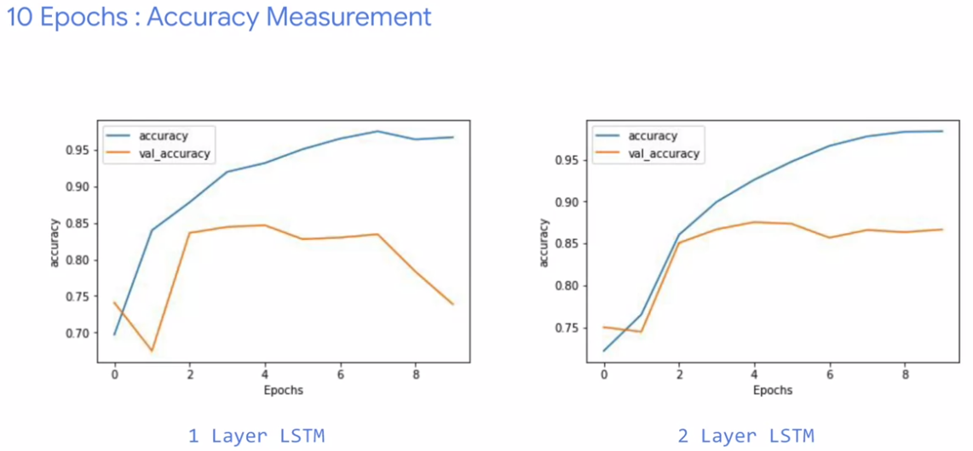

* Here's the comparison of accuracies between the one layer LSTM and the two layer one over 10 epochs.
* There's not much of a difference except the nosedive and the validation accuracy.
* But notice how the training curve is smoother.
* *I found from training networks that jaggedness can be an indication that your model needs improvement, and the single LSTM that you can see here is not the smoothest.*
* If you look at loss, over the first 10 epochs, we can see similar results.

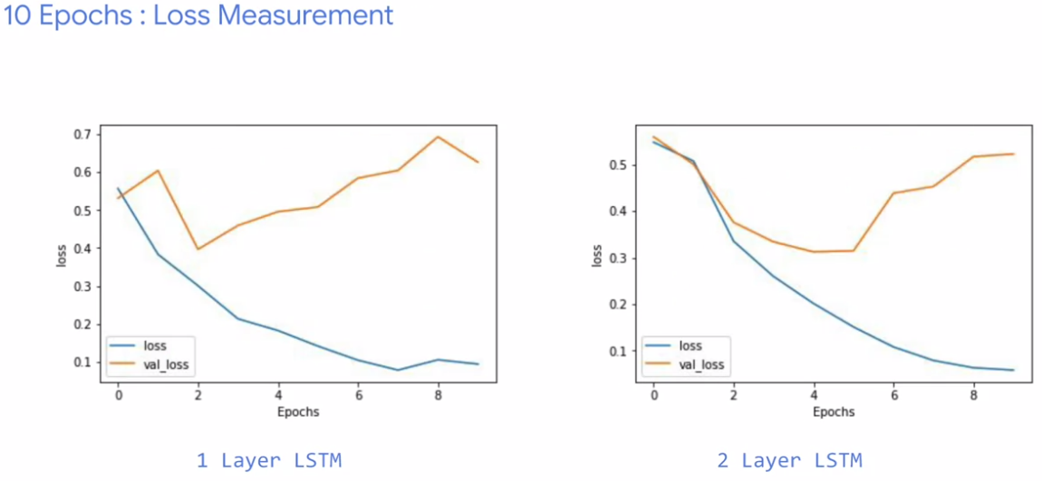

* But look what happens when we increase to 50 epochs training.

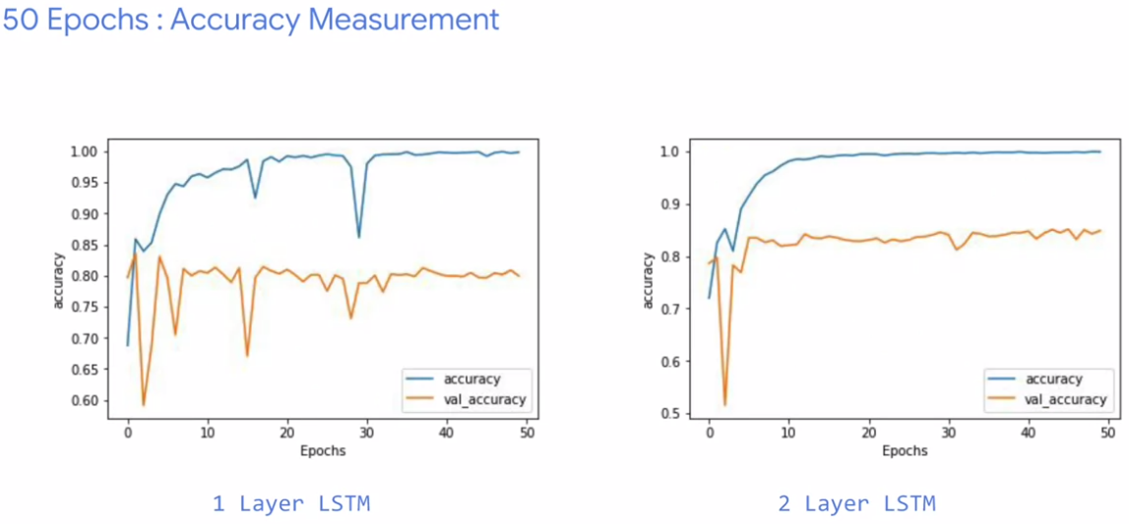

* Our one layer LSTM, while climbing in accuracy, is also prone to some pretty sharp dips.
* The final result might be good, but those dips make me suspicious about the overall accuracy of the model.
* Our two layer one looks much smoother, and as such makes me much more confident in its results.
* Note also the validation accuracy.
* Considering it levels out at about 80 percent, it's not bad given that the training set and the test set were both 25,000 reviews.
* But we're using 8,000 sub-words taken only from the training set.
* So there would be many tokens in the test sets that would be out of vocabulary.
* Yet despite that, we are still at about 80% accuracy.
* Our loss results are similar with the two layer having a much smoother curve.

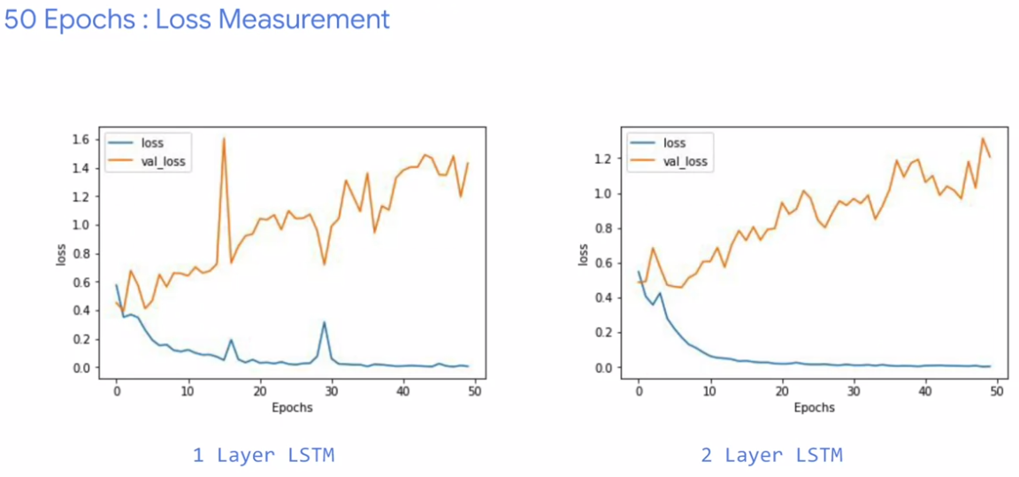

* The loss is increasing epoch by epoch.
* So that's worth monitoring to see if it flattens out in later epochs as would be desired.
* I hope this was a good introduction into how RNNs and LSTMs can help you with text classification.
* Their inherent sequencing is great for predicting unseen text if you want to generate some, and we'll see that later.

#### A word from Laurence

* Earlier we saw LSTMs and how they work with cell state to help keep context in a way that helps with understanding language.
* Well, words that aren't immediate neighbours can affect each other's context.
* Next, you'll see some other options of RNN including convolutions, Gated Recurrent Units also called GRUs, and more on how you can write the code for them.
* You'll investigate the impact that they have on training.
* I'm not going to go into depth on how they work, and that information is available in the deep learning specialization from Andrew. So do check it out there.

#### Looking into the code

* So let's start with this basic neural network.
* It has an embedding taking my vocab size, embedding dimensions, and input length as usual.
* The output from the embedding is flattened, averaged, and then fed into a dense neural network.

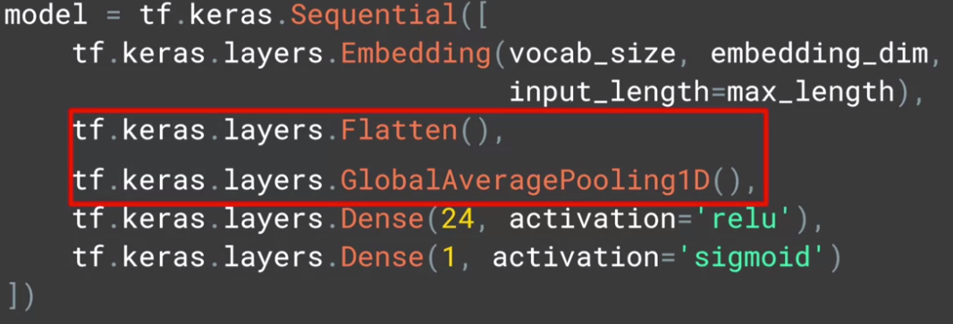

* But we can experiment with the layers that bridge the embedding and the dense by removing the flatten and puling from here, and replacing them with an LSTM like this.

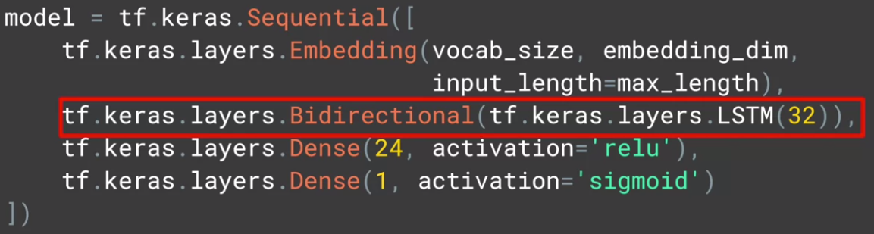

* After training using the sarcasm data-set with these, when just using the pooling and flattening, I quickly got close to 85% accuracy and then it flattened out there.

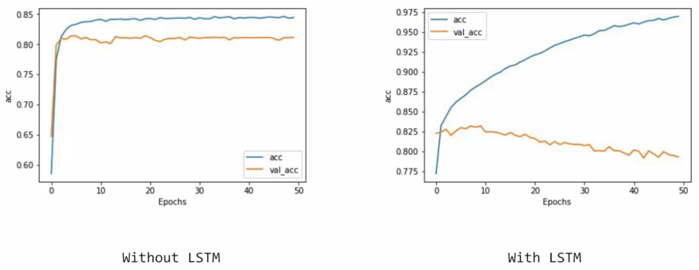

* The validation set was a little less accurate, but the curves we're quite in sync.
* On the other hand, when using LSTM, I reached 85% accuracy really quickly and continued climbing towards about 97.5% accuracy within 50 epochs.
* The validation set dropped slowly, but it was still close to the same value as the non- LSTM version.
* *Still the drop indicates that there's some over fitting going on here.*
* So a bit of tweaking to the LSTM should help fix that.

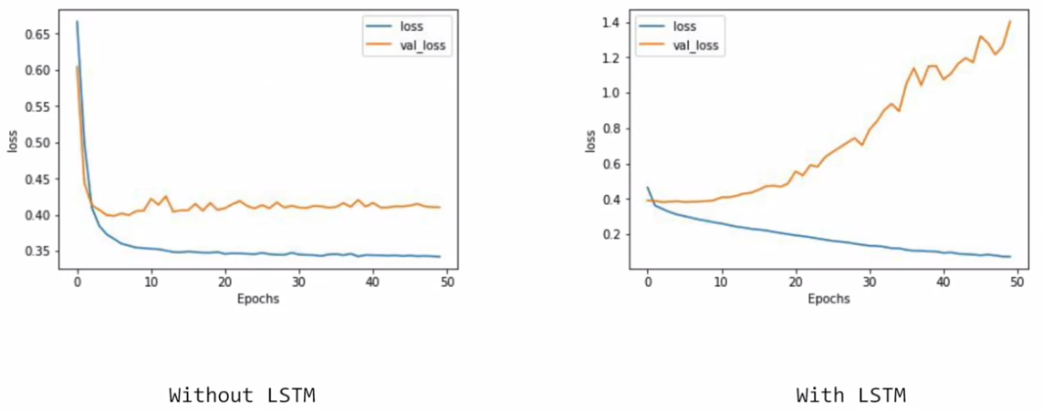

* Similarly, the loss values from my non-LSTM one got to healthy state quite quickly and then flattened out.
* Whereas with the LSTM, the training loss dropped nicely, but the validation one increased as I continue training.
* Again, this shows some over fitting in the LSTM network.
* While the accuracy of the prediction increased, the confidence in it decreased.
* So you should be careful to adjust your training parameters when you use different network types, it's not just a straight drop-in like I did here.

#### Using a convolutional network

* Another type of layer that you can use is a convolution, in a very similar way to what you did with images.

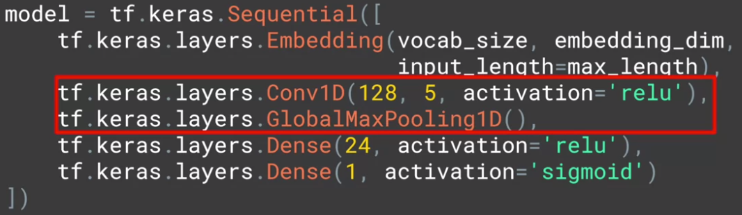

* The code to use a convolutional on network is here.
* It's very similar to what you had before. You specify the number of convolutions that you want to learn, their size, and their activation function.
* The effect of this will then be the same.
* Now words will be grouped into the size of the filter in this case 5.
* And convolutions will be learned that can map the word classification to the desired output.

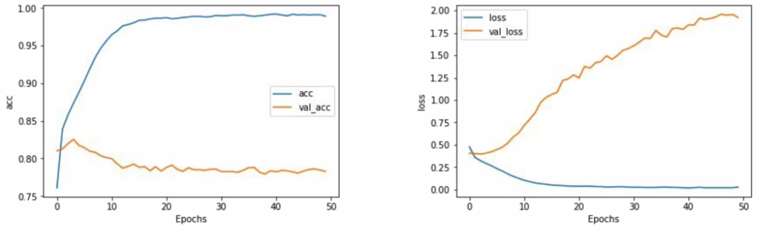

* If we train with the convolutions now, we will see that our accuracy does even better than before with close to about 100% on training and around 80% on validation.
* But as before, our loss increases in the validation set, indicating potential overfitting.
* As I have a super simple network here, it's not surprising, and it will take some experimentation with different combinations of conversational layers to improve on this.
* If we go back to the model and explore the parameters, we'll see that we have 128 filters each for 5 words.

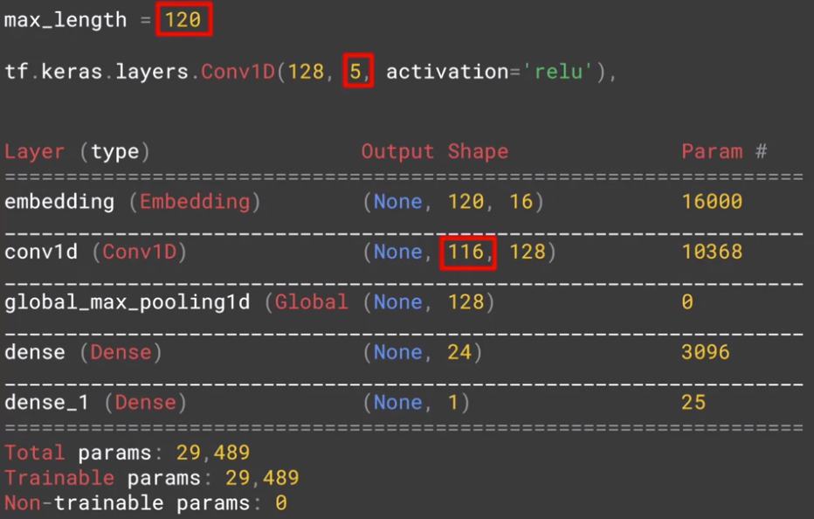

* And an exploration of the model will show these dimensions.
* As the size of the input was 120 words, and a filter that is 5 words long will shave off 2 words from the front and back, leaving us with 116.
* The 128 filters that we specified will show up here as part of the convolutional layer.

## Check out the code!

Spend some time going through this notebook to see how it works.

[IMDB Subwords 8K with 1D Convolutional Layer](https://colab.research.google.com/github/lmoroney/dlaicourse/blob/master/TensorFlow%20In%20Practice/Course%203%20-%20NLP/Course%203%20-%20Week%203%20-%20Lesson%201c.ipynb)

#### Going back to the IMDB dataset

* So now that we've seen these, let's go back to the IMDB dataset that we used earlier.

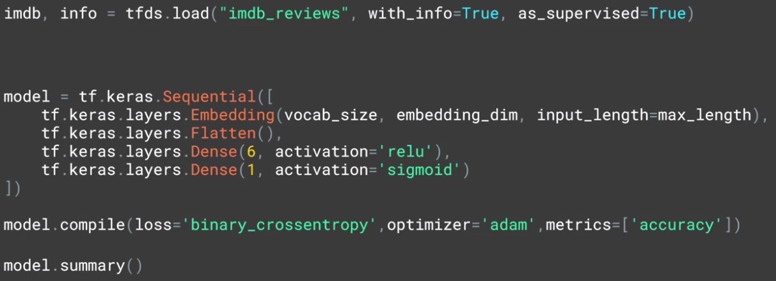

* Here, I'll just use an embedding that I flattened before it goes into the dense.

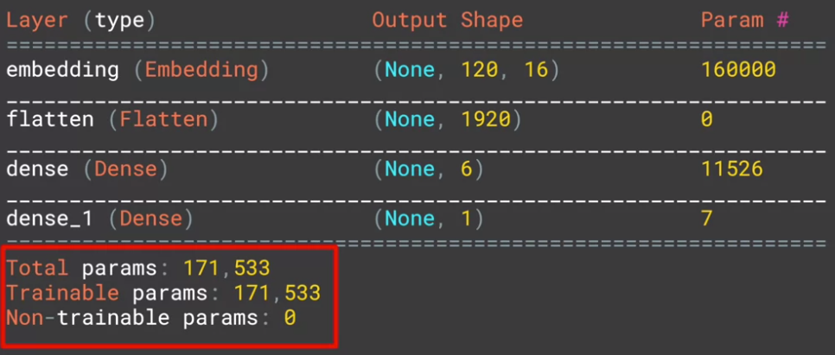

* My model will look like this, with a 171,533 parameters, and the performance will be like this.

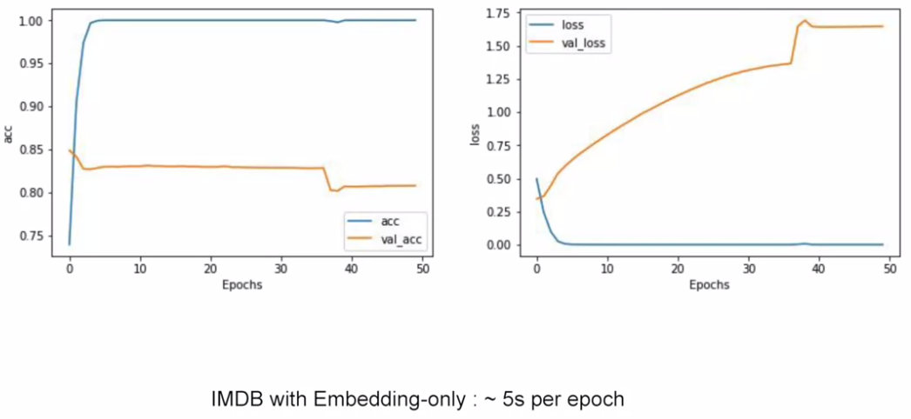

* It's nice accuracy, but clear overfitting but it only takes about five seconds per epoch to train.

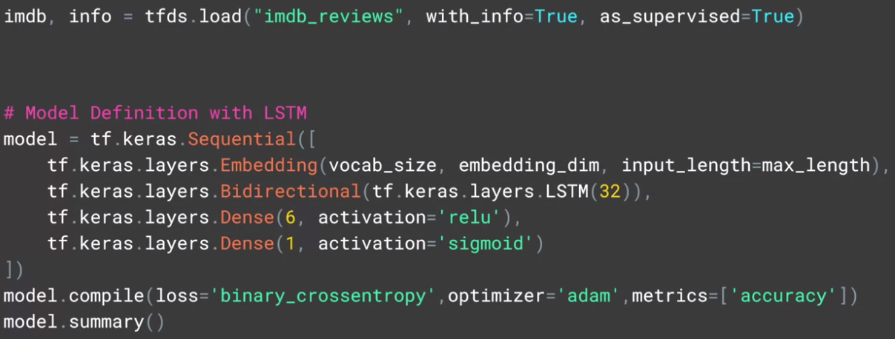

* If I change this to use an LSTM, I'll now have only 30,129 parameters, but it will take about 43 seconds per epoch.

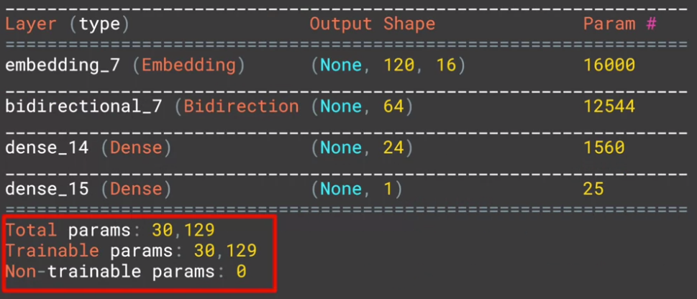

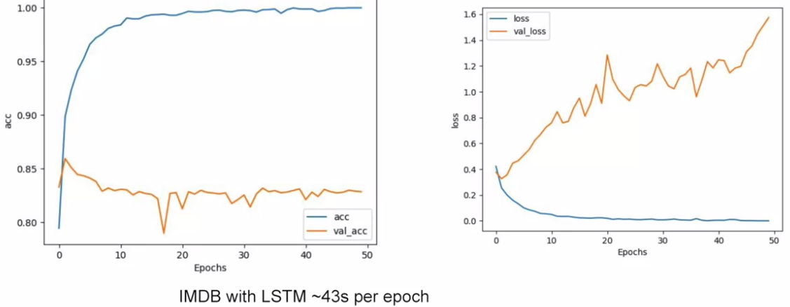

* The accuracy is better, but there's still some overfitting.
* If I try a GRU layer instead, with a GRU being a different type of RNN, and I make it bidirectional, my network will have 169,997 parameters.

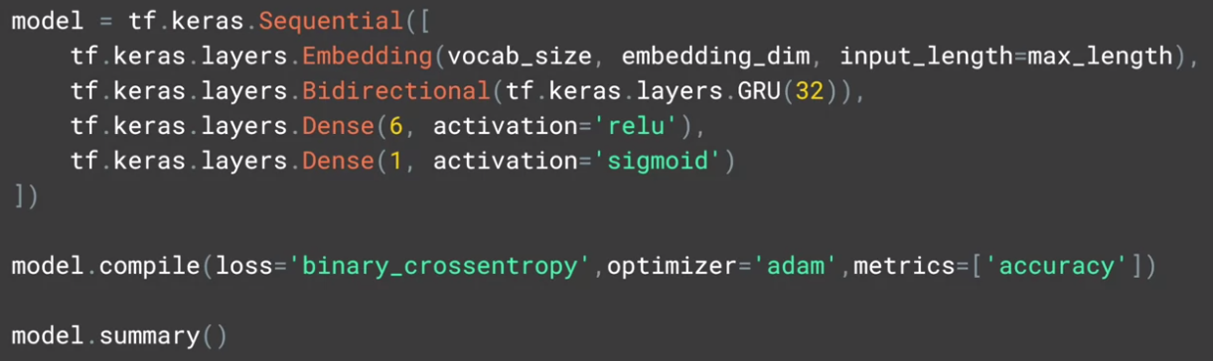

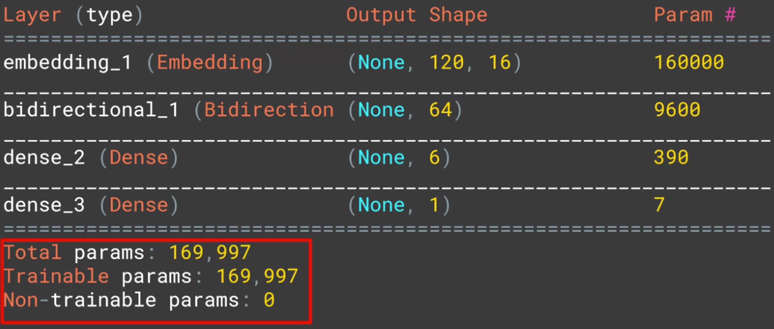

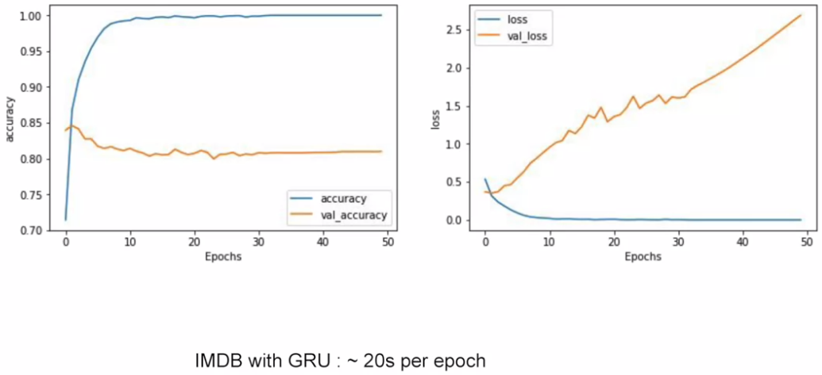

* My training time will fall to 20 seconds per epoch, and my accuracy is again very good on training and not too bad on validation but again, showing some overfitting.
* With a convolutional network, I'll have a 171,149 parameters and it only takes about six seconds per epoch to get me close to 100% accuracy on training, and about 83% on validation, but again with overfitting.

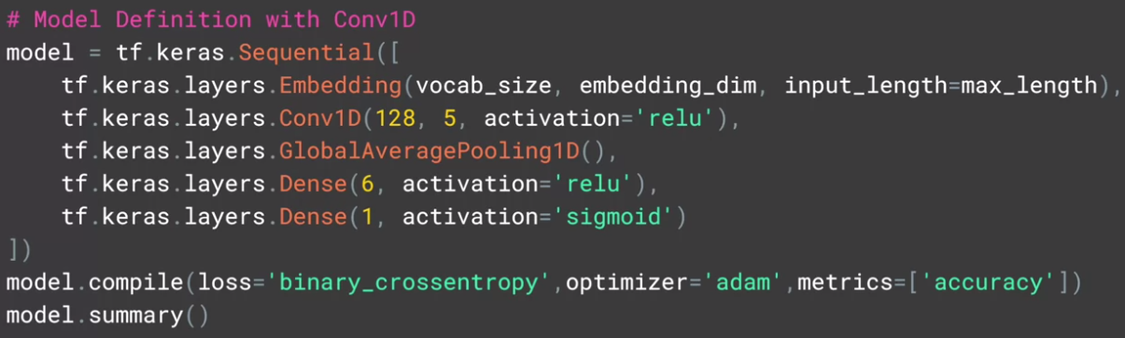

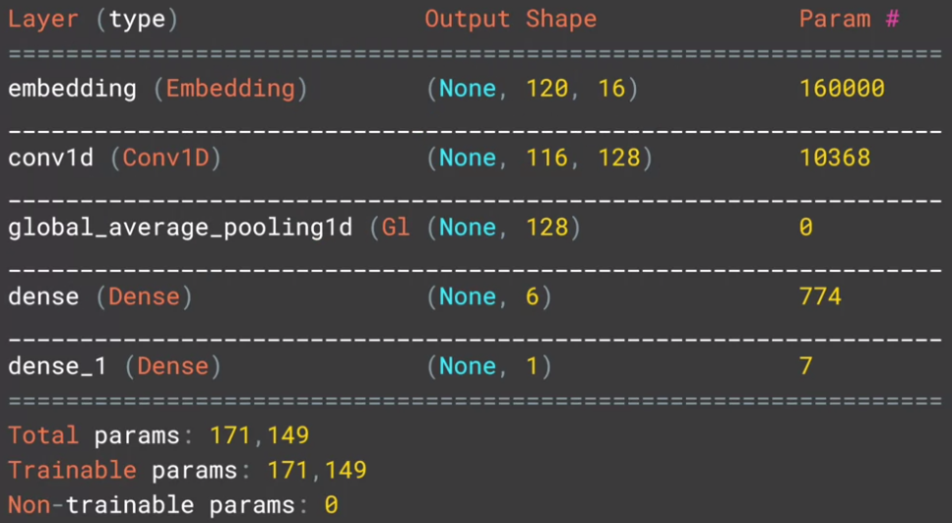

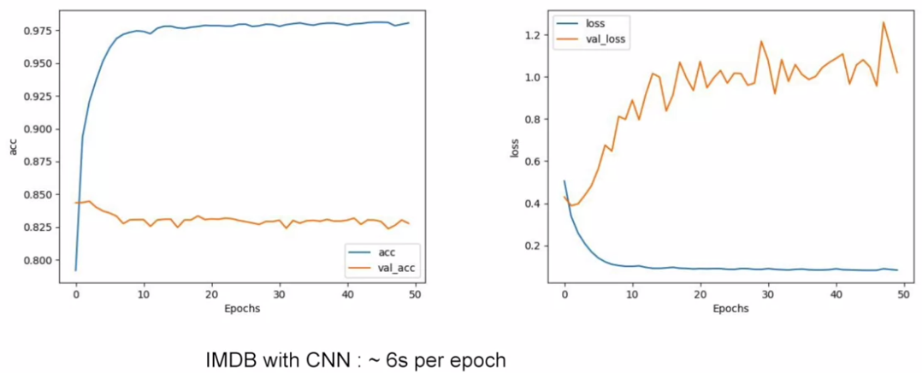

## Check out the code!

Spend some time going through this notebook to see how it works and what the impact of different layer types have on training for classification.

[IMDB Reviews with GRU (and optional LSTM and Conv1D)](https://colab.research.google.com/github/lmoroney/dlaicourse/blob/master/TensorFlow%20In%20Practice/Course%203%20-%20NLP/Course%203%20-%20Week%203%20-%20Lesson%202d.ipynb#scrollTo=nHGYuU4jPYaj)

## Exploring different sequence models

We've created a number of notebooks for you to explore the different types of sequence model.

Spend some time going through these to see how they work, and what the impact of different layer types have on training for classification.

[Sarcasm with Bidirectional LSTM](https://colab.research.google.com/github/lmoroney/dlaicourse/blob/master/TensorFlow%20In%20Practice/Course%203%20-%20NLP/Course%203%20-%20Week%203%20-%20Lesson%202.ipynb#scrollTo=g9DC6dmLF8DC)

[Sarcasm with 1D Convolutional Layer](https://colab.research.google.com/github/lmoroney/dlaicourse/blob/master/TensorFlow%20In%20Practice/Course%203%20-%20NLP/Course%203%20-%20Week%203%20-%20Lesson%202c.ipynb#scrollTo=g9DC6dmLF8DC)

#### Introduction to sequence models and literature

* We've seen classification of text over the last few lessons.
* But what about if we want to generate new text.
* Instead of generating new text, how about thinking about it as a prediction problem.
* Remember when for example you had a bunch of pixels for a picture, and you trained a neural network to classify what those pixels were, and it would predict the contents of the image, like maybe a fashion item, or a piece of handwriting.
* Well, text prediction is very similar.
* We can get a body of texts, extract the full vocabulary from it, and then create datasets from that, where we make it phrase the Xs and the next word in that phrase to be the Ys.
* For example, consider the phrase, Twinkle, Twinkle, Little, Star.
* What if we were to create training data where the Xs are Twinkle, Twinkle, Little, and the Y is star.
* Then, whenever neural network sees the words Twinkle, Twinkle, Little, the predicted next word would be star.
* Thus given enough words in a corpus with a neural network trained on each of the phrases in that corpus, and the predicted next word, we can come up with some pretty sophisticated text generation.

#### Looking into the code

* So let's start with a simple example.

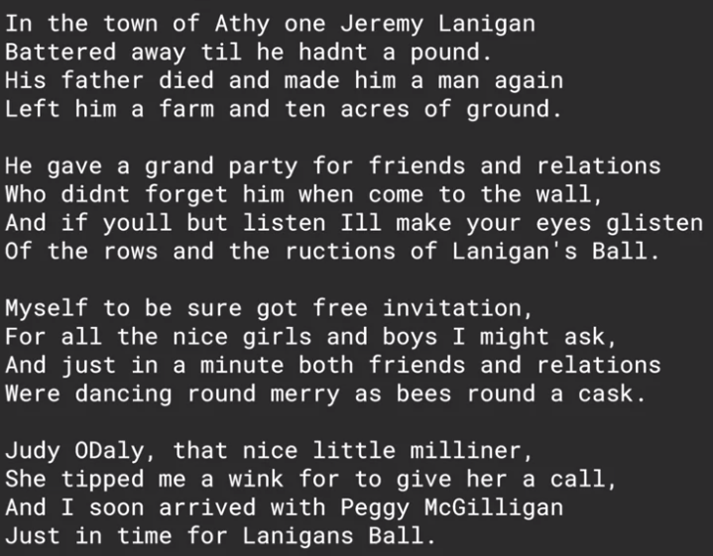

* I've taken a traditional Irish song and here are the first few words of it, and here's the beginning of the code to process it.
* In this case to keep things simple, I put the entire song into a single string.

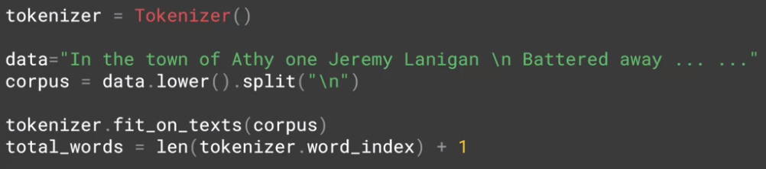

* You can see that string here and I've denoted line breaks with \n.
* Then, by calling the split function on \n, I can create a Python list of sentences from the data and I'll convert all of that to lowercase.
* Using the tokenizer, I can then call fit_on_texts to this corpus of work and it will create the dictionary of words and the overall corpus.
* This is a key value pair with the key being the word and the value being the token for that word.
* We can find the total number of words in the corpus, by getting the length of its word_index. We'll add one to this, to consider outer vocabulary words.

#### Training the data

* So now, let's look at the code to take this corpus and turn it into training data.

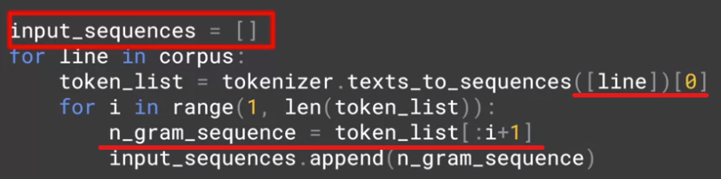

* First of all, our training x's will be called input sequences, and this will be a Python list.
* Then for each line in the corpus, we'll generate a token list using the tokenizers, texts to sequences method.

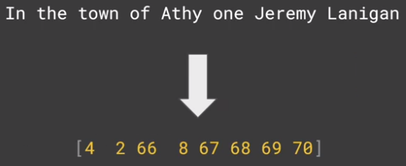

* This will convert a line of text like, "In the he town of Athy one Jeremy Lanigan," into a list of the tokens representing the words.
* Then we'll iterate over this list of tokens and create a number of n-grams sequences, namely the first two words in the sentence or one sequence, then the first three are another sequence etc.
* The result of this will be, for the first line in the song, the following input sequences that will be generated.
* The same process will happen for each line, but as you can see, the input sequences are simply the sentences being broken down into phrases, the first two words, the first three words, etc.
* We next need to find the length of the longest sentence in the corpus.



* To do this, we'll iterate over all of the sequences and find the longest one with code like this.
* Once we have our longest sequence length, the next thing to do is pad all of the sequences so that they are the same length.



* We will pre-pad with zeros to make it easier to extract the label, you'll see that in a few moments.

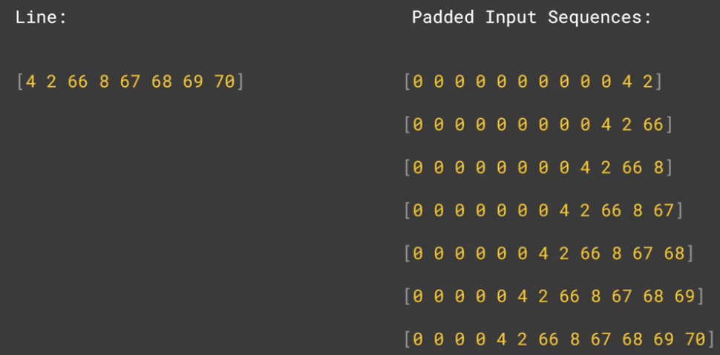

* So now, our line will be represented by a set of padded input sequences that looks like this.
* Now, that we have our sequences, the next thing we need to do is turn them into x's and y's, our input values and their labels.
* When you think about it, now that the sentences are represented in this way, all we have to do is take all but the last character as the x and then use the last character as the y on our label.

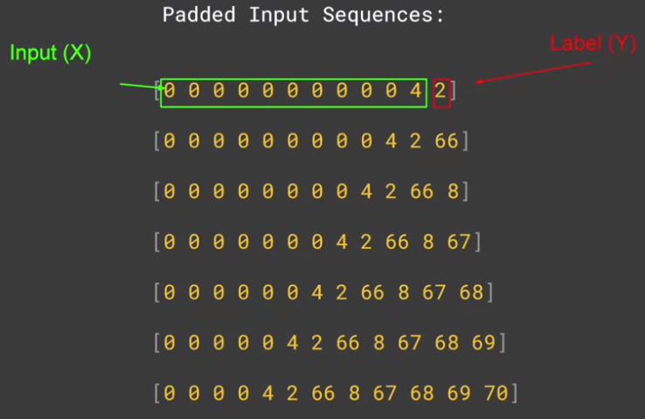

* We do that like this, where for the first sequence, everything up to the four is our input and the two is our label.
* Similarly, for the second sequence where the input is two words and the label is the third word, tokenized to 66.
* By this point, it should be clear why we did pre-padding, because it makes it much easier for us to get the label simply by grabbing the last token.

#### More on training the data

* So now, we have to split our sequences into our x's and our y's.

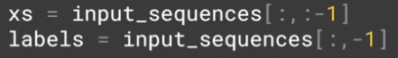

* To do this, let's grab the first n tokens, and make them our x's.
* We'll then get the last token and make it our label.
* Before the label becomes a y, there's one more step, and you'll see that shortly.
* Python makes this really easy to do with its less syntax.
* So to get my x's, I just get all of the input sequences sliced to remove the last token.
* To get the labels, I get all of the input sequence sliced to keep the last token.
* Now, I should one-hot encode my labels as this really is a classification problem.



* Where given a sequence of words, I can classify from the corpus, what the next word would likely be.
* So to one-hot encode, I can use the contrast utility to convert a list to a categorical.
* I simply give it the list of labels and the number of classes which is my number of words, and it will create a one-hot encoding of the labels.

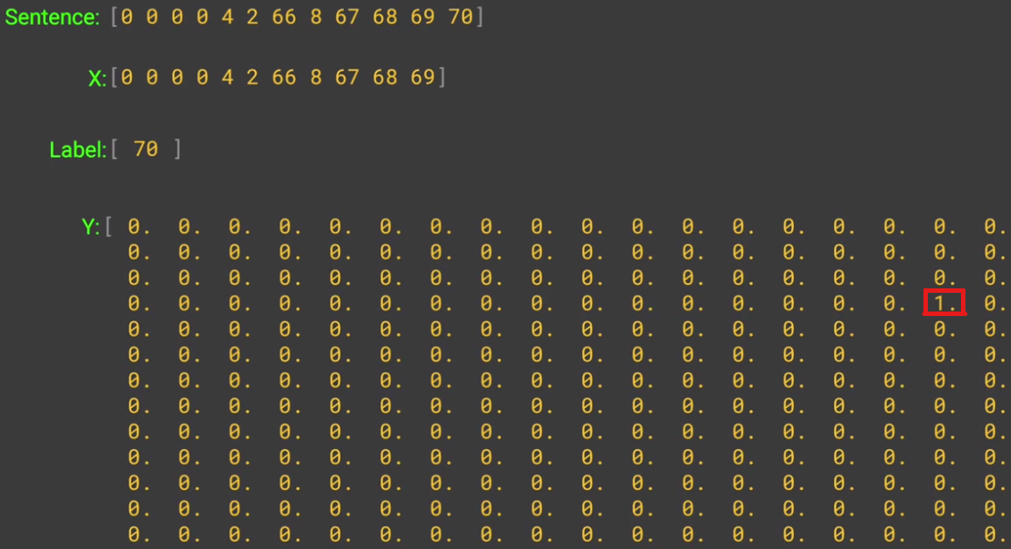

* So for example, if we consider this list of tokens as a sentence, then the x is the list up to the last value, and the label is the last value which in this case is 70.
* The y is a one-hot encoded array whether length is the size of the corpus of words and the value that is set to one is the one at the index of the label which in this case is the 70th element.
* Okay. You now have all of the data ready to train a network for prediction.
* Hopefully, this was useful for you.

## Check out the code!

Let's take a look at the first [notebook](https://colab.research.google.com/github/lmoroney/dlaicourse/blob/master/TensorFlow%20In%20Practice/Course%203%20-%20NLP/Course%203%20-%20Week%204%20-%20Lesson%201%20-%20Notebook.ipynb).

#### Finding what the next word should be

* Earlier, we looked at the data, a string containing a single song, and saw how to prepare that for generating new text. We saw how to tokenize the data and then create sub-sentence n-grams that were labelled with the next word in the sentence.
* We then one-hot encoded the labels to get us into a position where we can build a neural network that can, given a sentence, predict the next word.
* Now that we have our data as xs and ys, it's relatively simple for us to create a neural network to classify what the next word should be, given a set of words.
* Here's the code.

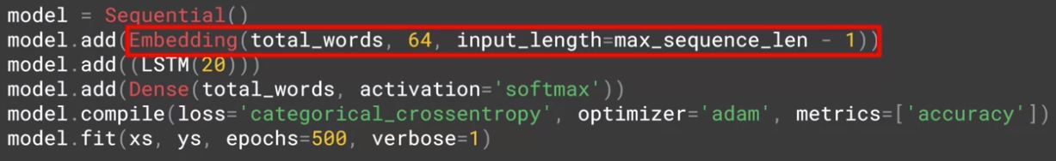

* We'll start with an embedding layer.
  + We'll want it to handle all of our words, so we set that in the first parameter.
  + The second parameter is the number of dimensions to use to plot the vector for a word.
  + Feel free to tweak this to see what its impact would be on results, but I'm going to keep it at 64 for now.
  + Finally, the size of the input dimensions will be fed in, and this is the length of the longest sequence minus 1.
  + We subtract one because we cropped off the last word of each sequence to get the label, so our sequences will be one less than the maximum sequence length.
* Next we'll add an LSTM.
  + As we saw with LSTMs earlier, their cell state means that they carry context along with them, so it's not just next door neighbour words that have an impact.
  + I'll specify 20 units here, but again, you should feel free to experiment.
* Finally there's a dense layer sized as the total words, which is the same size that we used for the one-hot encoding. Thus this layer will have one neuron, per word and that neuron should light up when we predict a given word.
* We're doing a categorical classification, so we'll set the laws to be categorical cross entropy.
  + And we'll use the adam optimizer, which seems to work particularly well for tasks like this one.
* Finally, we'll train for a lot of epoch, say about 500, as it takes a while for a model like this to converge, particularly as it has very little data.
* So if we train the model for 500 epochs, it will look like this.

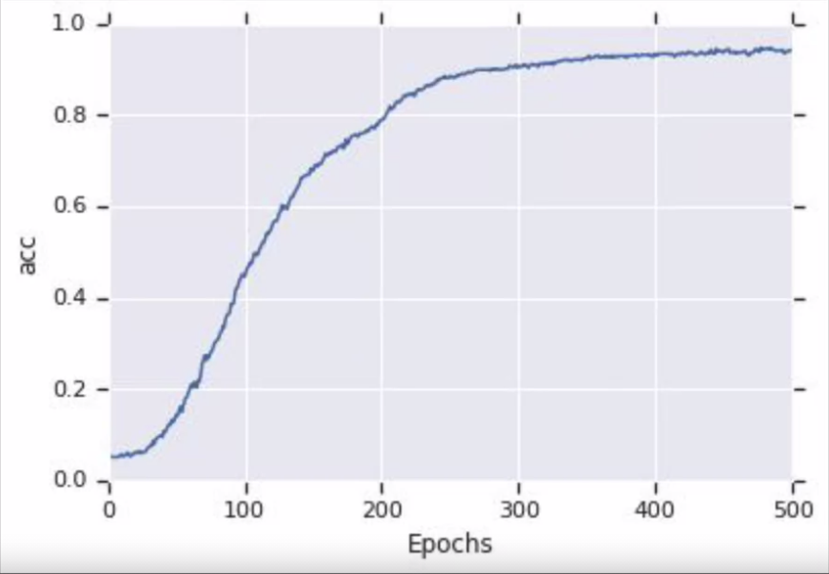

#### Example



* Here are a few phrases that were generated when I gave the neural network the sentence Lawrence went to Dublin, and I asked it to predict the next 10 words.
* We'll see the code for that in a moment, but notice that there's a lot of repetition of words.
* In this sentence, three of the last five words are wall, and here three of the last four are ball, and even in this one the word relations gets repeated.
* This is because our LSTM was only carrying context forward.

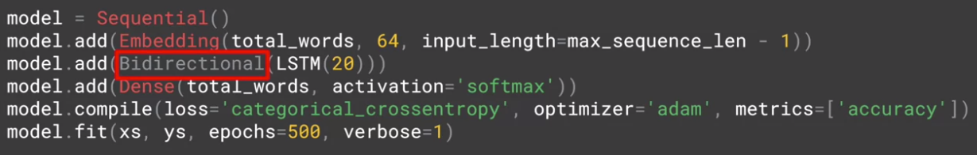

* Let's take a look at what happens if we change the code to be bidirectional.
* By adding this line simply defining the LSTM is bidirectional, and then retraining, I can see that I do converge a bit quicker as you'll see in this chart.

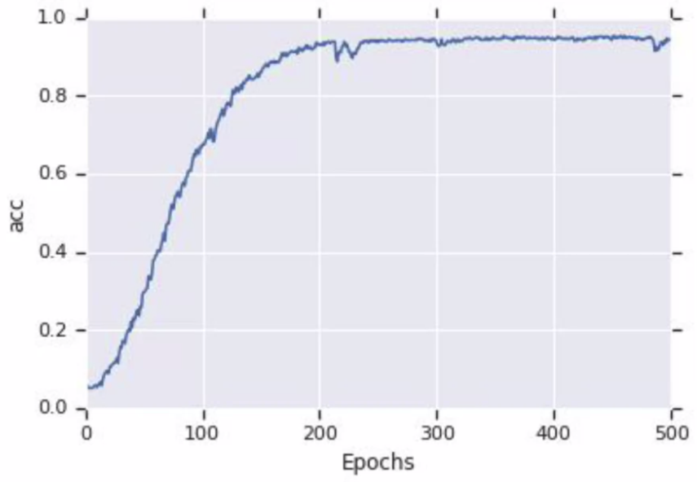

* After training and testing, I now get these sentences.



* They make a little bit more sense, but there's still some repetition.
* That being said, remember this is a song where words rhyme such as ball, all and wall, etc, and as such many of them are going to show up.

#### Predicting a word

* So now, let's take a look at how to get a prediction for a word and how to generate new text based on those predictions.
* So let's start with a single sentence. For example, **'Lawrence went to Dublin.'**
* I'm calling this sentence the seed.
* If I want to predict the next 10 words in the sentence to follow this, then this code will tokenize that for me using the text to sequences method on the tokenizer.



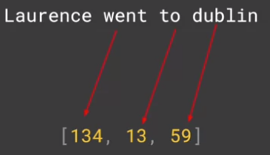

* As we don't have an outer vocabulary word, it will ignore 'Lawrence,' which isn't in the corpus and will get the following sequence.



* This code will then pad the sequence so it matches the ones in the training set.



* So we end up with something like this which we can pass to the model to get a prediction back.



* This will give us the token of the word most likely to be the next one in the sequence.

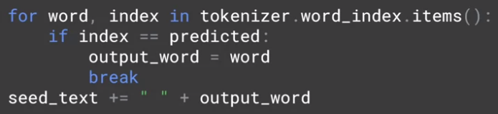

* So now, we can do a reverse lookup on the word index items to turn the token back into a word and to add that to our seed texts, and that's it.

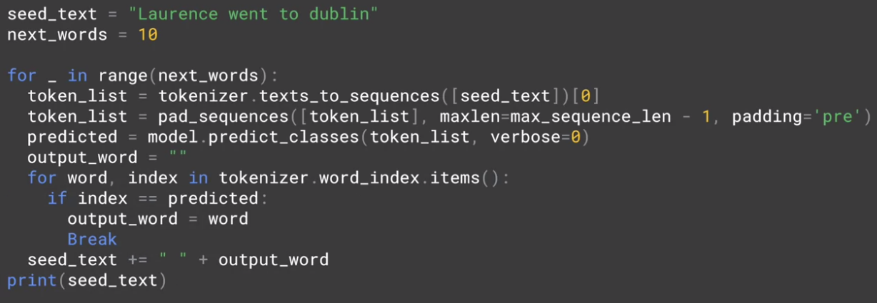

* Here's the complete code to do that 10 times and you can tweak it for more.
* But do you know that the more words you predict, the more likely you are going to get gibberish! Because each word is predicted, so it's not 100% certain, and then the next one is less certain, and the next one, etc.
* So for example, if you try the same seed and predict 100 words, you'll end up with something like this.

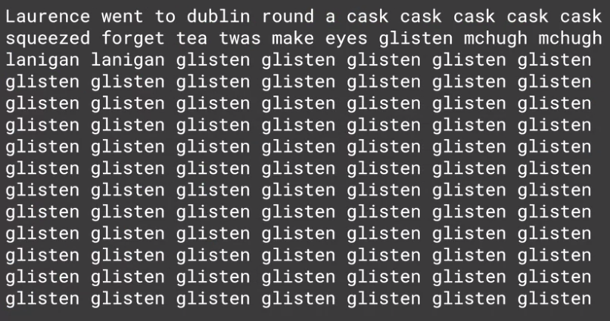

* Using a larger corpus we'll help, and then, you'll see the impact of that, as well as some tweaks that a neural network that will help you create poetry.

#### Poetry!

* Earlier, we used the single song to generate text.
* We got some text from it but once we tried to predict beyond a few words, it rapidly became gibberish.
* So next, we'll take a look at adapting that work for a larger body of words to see the impact.
* The good news is that it will require very little code changes, so you'll be able to get it working quite quickly.
* I've prepared a file with a lot of songs that has 1,692 sentences in all to see what the impact would be on the poetry that a neural network would create.
* To download these lyrics, you can use this code.

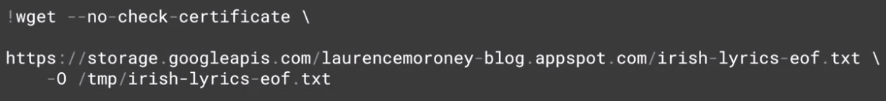

## Link to Laurence's poetry

Please find the link to Laurence’s generated poetry [here](https://storage.googleapis.com/laurencemoroney-blog.appspot.com/irish-lyrics-eof.txt).

#### Looking into the code



* Now instead of hard-coding the song into a string called data, I can read it from the file like this.
* I've updated the model a little bit to make it work better with a larger corpus of work but please feel free to experiment with these hyper-parameters.

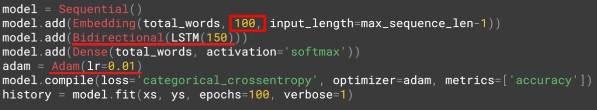

* Three things that you can experiment with.
* First, is the dimensionality of the embedding, 100 is purely arbitrary and I'd love to hear what type of results you will get with different values.
* Similarly, I increase the number of LSTN units to 150.
* Again, you can try different values or you can see how it behaves if you remove the bidirectional.
* Perhaps you want words only to have forward meaning, where big dog makes sense but dog big doesn't make so much sense.
* Perhaps the biggest impact is on the optimizer. Instead of just hard coding Adam as my optimizer this time and getting the defaults, I've now created my own Adam optimizer and set the learning rate on it.
* Try experimenting with different values here and see the impact that they have on convergence.
* In particular, see how different convergences can create different poetry.
* And of course, training for different epochs will always have an impact with more generally being better but eventually you'll hit the law of diminishing returns.

#### Laurence the poet!

* In a co-lab with this data and these parameters, using a GPU, it typically takes about 20 minutes to train a model.
* Once it's done, try a a seed sentence and get it to give you 100 words.
* Note that there are no line breaks in the prediction, so you'll have to add them manually to turn the word stream into poetry.
* Here's a simple example.
* I used a famous quote from a very famous movie and let's see if you can recognize it.
* And I tried that to see what type of poem it would give me and I got this.
* And it almost makes sense, [LAUGH] but that's poetry for you.

Help me Obi-Wan Kenobi, you're my only hope.

My dear and hope as I did fly with its flavours, along with all its joys.

But sure I will build, love you still, gold it did join.

Do mans run away cross our country, our wedding I was down to.

Off holyhead wished myself down among the pigs.

Played some hearty Riggs, me embarrass.

Find me brother, me chambers she gave me her story.

Be Irishmen to greet you lovely Molly.

Gone away from me home, home to leave the old tin cans.

The foreman's chain once was shining.

Sky above I think I love.

## Check out the code!

Let's take a look at the second [notebook](https://colab.research.google.com/github/lmoroney/dlaicourse/blob/master/TensorFlow%20In%20Practice/Course%203%20-%20NLP/Course%203%20-%20Week%204%20-%20Lesson%202%20-%20Notebook.ipynb) for this week.

#### Your next task

* Now, this approach works very well until you have very large bodies of text with many many words.
* So for example, you could try the complete works of Shakespeare and you'll likely hit memory errors, as assigning the one-hot encodings of the labels to matrices that have over 31,477 elements, which is the number of unique words in the collection, and there are over 15 million sequences generated using the algorithm that we showed here.
* So the labels alone would require the storage of many terabytes of RAM.
* So for your next task, you'll go through a workbook by yourself that uses character-based prediction.
* The full number of unique characters in a corpus is far less than the full number of unique words, at least in English.
* So the same principles that you use to predict words can be used to apply here.



## Link to generating text using a character-based RNN

Find the link to generating text using a character-based RNN [here](https://www.tensorflow.org/tutorials/sequences/text_generation).

## Wrap up

Over the last four weeks you've gotten a grounding in how to do Natural Language processing with TensorFlow and Keras. You went from first principles -- basic Tokenization and Padding of text to produce data structures that could be used in a Neural Network.

You then learned about embeddings, and how words could be mapped to vectors, and words of similar semantics given vectors pointing in a similar direction, giving you a mathematical model for their meaning, which could then be fed into a deep neural network for classification.

From there you started learning about sequence models, and how they help deepen your understanding of sentiment in text by not just looking at words in isolation, but also how their meanings change when they qualify one another.

You wrapped up by taking everything you learned and using it to build a poetry generator!

This is just a beginning in using TensorFlow for natural language processing. I hope it was a good start for you, and you feel equipped to go to the next level!